Read and Try: Ratio and Proportion
A ratio is a comparison of two quantities. You can write the ratio of a to b or a : b as the quotient when b ≠ 0. Unless otherwise stated, the terms and expressions appearing in ratios in this book are assumed to be nonzero.
You can read a : b as "the ratio a to b."
Example: Photography A photo that is 8 in. wide and $5\frac{1}{3}$ in. high is enlarged to a poster that is 2 ft wide and $1\frac{1}{3}$ ft high. What is the ratio of the width of the photo to the width of the poster?
The ratio of width of photo to width of poster is 1 : 3 or .
A proportion is a statement that two ratios are equal. You can write a proportion in these forms:
= and a : b = c : d
When three or more ratios are equal, you can write an extended proportion. For example, you could write:
= =

Properties of Proportions
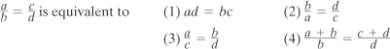
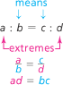
Multiplying both sides of = by bd results in the first property, called the Cross-Product Property. You may state this property as "The product of the extremes is equal to the product of the means."

Example: Properties of Proportions
If$\frac{x}{y}=\frac{5}{6}$, complete each statement.
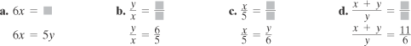

Solving for a Variable: We solve for a variable by first cross multiplying:
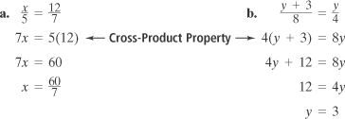
Practice:



