Chapter 10 - Surface Area & Volume Name:_____________________________________________

_________________________________ – amount of space that a 3-dimensional object takes up
Important to know how much a container will hold
Also tells you how much space is required to store objects

Volume is measured using _________________________ units
Example 1: Find the volume of the prism.

Example 2: Find the volume of the prism.

Example 3: Find the volume of the cylinder.

Example 4: Find the volume of the pyramid.

Example 5: Find the volume of the cone.

Example 6: Find the volume of the sphere
Volume of Prisms

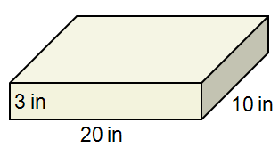
Volume of a rectangular prism:

Volume of other prisms:

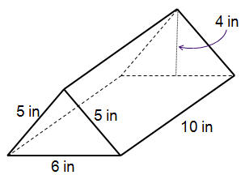

Volume of a Cylinder

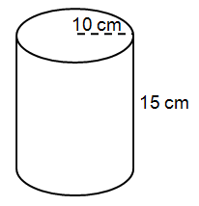
Volume of Pyramids

You must use an altitude as the height, not the slant height!

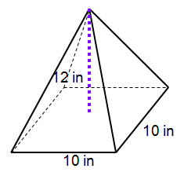
Volume of a Cone

Volume of a Sphere



