10.5, 6, 7 – Volume of Prisms, Cylinders, Pyramids, Cones, and Spheres Name:____________________________________

______________________ – amount of space that a 3-dimensional object takes up
Important to know how much a container will hold
Also tells you how much space is required to store objects
Volume is measured using ______________ ______________

Volume of a Prism:
Volume of a rectangular prism equals _________________ x ________________ x _________________

For other prisms volume is __________________________________ x __________________

Example 1: Find the volume of the prism using a formula.
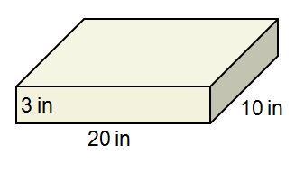
Example 2: Find the volume of the cylinder using a formula.
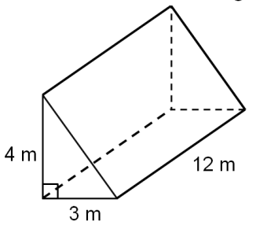

Volume of a Cylinder:

Example 3: Find the volume of the cylinder using a formula.
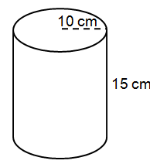

Volume of a Pyramid:
If you have a pyramid and a prism with the same base area and height, the pyramid has one third the volume of the prism.

You must use the altitude as the height, not the slant height!
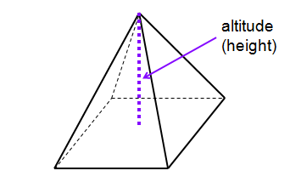
Example 4: Find the volume.
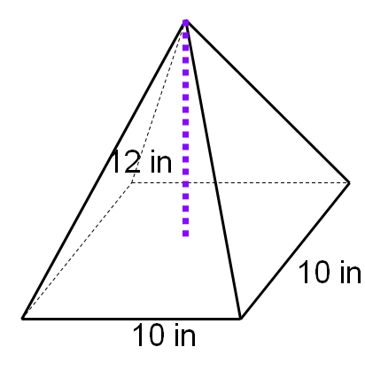

Volume of a Cone:
If you have a cone and a cylinder with the same radius and height, the cone has one third the volume of the cylinder.

Example 5: Find the volume of the cone.
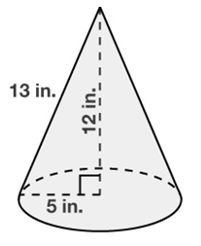
Example 6: Two cones are similar. The smaller cone has a height of 10 m and a base of with a radius of 6 m. The larger cone has a height of 15 m. What is the volume of the larger cone, in cubic meters?

Volume of a Sphere:
The volume of a sphere is four thirds the product of $π$ and the cube of the radius of the sphere.

Example 7: Find the volume of the sphere with radius of 6. Leave your answer in terms of $π$.

