10.4 – Surface Area of Pyramids, Cones, and Spheres Name:____________________________________

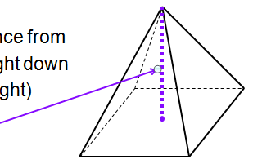
A _____________________________is a polyhedron with a base (can be any polygon) and other faces are triangles that meet at a common vertex.

_________________ – distance from top vertex straight down to the base (height)

__________________________ – distance from top vertex to bottom along one of the slanted sides

Sketch a net for the figure on the right.

Surface area of a pyramid equals ½ times perimeter of base times slant height plus the area of the base

Example 1: Find the surface area of the square pyramid using a formula.
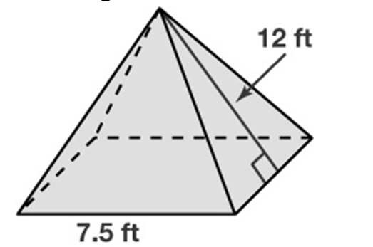

Example 2: Find the slant height and then use it to find the surface area of the pyramid.
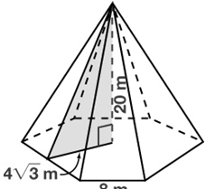

A _____________________________has a circular base and one curved surface that is pointed at the top like a pyramid.
The surface area of a cone equals circumference of base times slant height plus the area of the base

Example 3: Find the surface area of the cone.
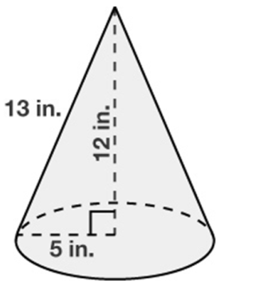

Example 4: Find the slant height then find the surface area of the cone.
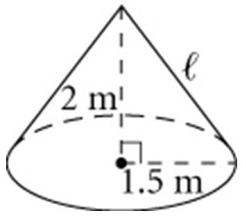

Example 5: A right circular cone has a height of 4 inches and a base with a diameter of 6 inches. What is the total surface area of the cone, in square inches?

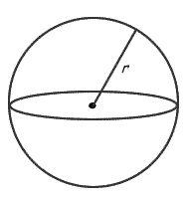
A __________________ is a set of all point in space _____________________________ from a given point called the _______________________________.
Surface Area of a Sphere:

Example 6: Find the surface area if a sphere with a diameter of 8 m. Leave your answer in terms of Π.

Example 7: Earth’s equator is about 24,902 mi long. Approximate the surface area of Earth by finding the surface area of a sphere with circumference 24,902 mi.

