Section 10.3 – Surface Area of Prisms and Cylinders Name:_____________________________________________

A _________________________ is a polyhedron with 2 parallel, congruent bases joined by several rectangles.
The other faces (rectangles that join the bases) are called _________________________________.
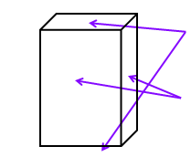
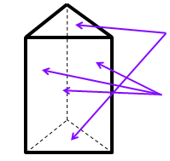
_____________________
_____________________

A _______________ is a two-dimensional pattern that you can fold to form a three-dimensional figure.
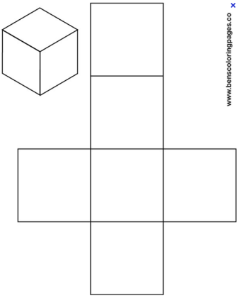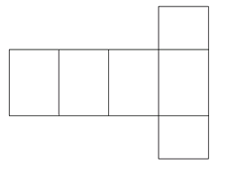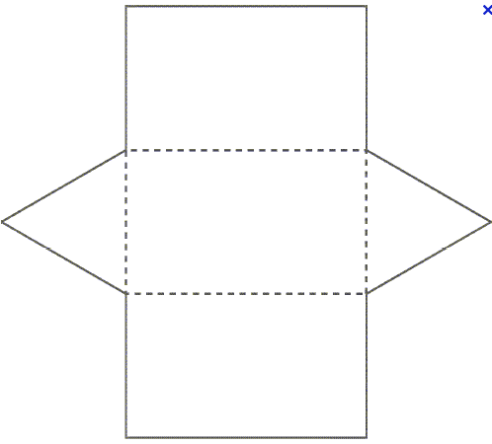

_____________________________________ – sum of the areas of each of the surfaces of a solid
How much paint it will take to cover the surface of an object?
How much cardboard it will take to make a box of a certain size?
Find the surface area of the cube using a net.

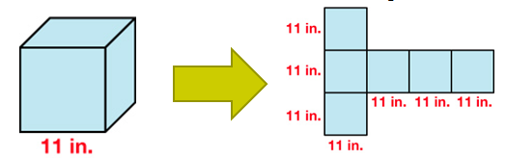

Surface area equals Lateral Area plus the area of the two Bases.

Lateral Area-_____________________________________________________________________________________________________________________

Example 1:
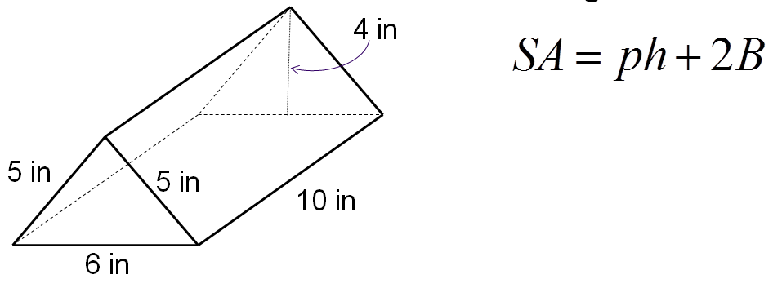
A _____________________________________ has two congruent circles as bases joined by a rolled up rectangle.
Since it has 2 bases and a lateral area the surface area can be found just like a prism.

We can adapt the surface area of a prism formula to help with cylinders.

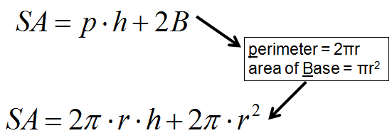
Example 2: Find the surface area of the cylinder using a formula.
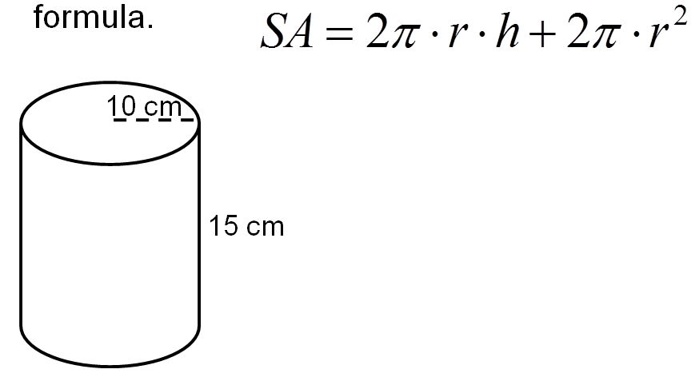

YOU TRY – Use formulas to find surface area of each solid.
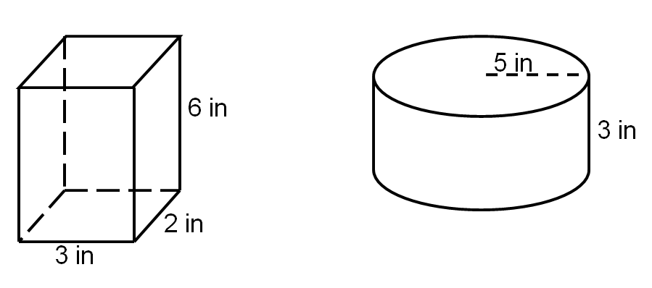

Example 3: An industrial technology student cuts a solid wood cube into 2 congruent pieces along the diagonals of opposite faces of the cube. The surface area of the cube is 54 in². What is the surface area, in square inches, of each prism created by the cut?

