COUNTING TAPE – PERCENT | PERCENT CIRCLE
DAILY VARIABLE GRAPH   | DAILY VARIABLE
DAILY CIRCLE   | DAILY DEPOSITOR  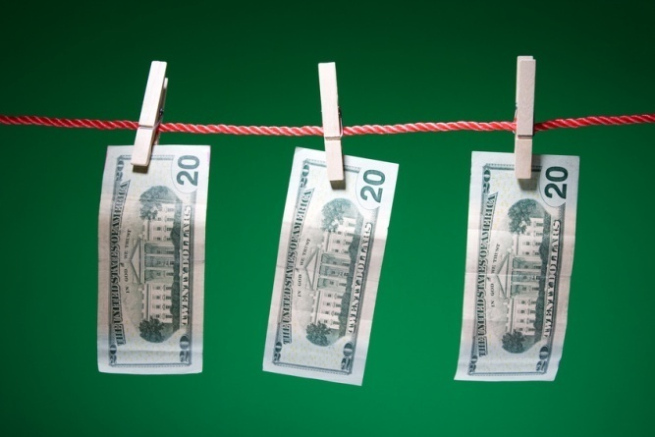
ARRAY   | DAILY PATTERN
AGENDA   | COUNTING TAPE – FRACTION
COUNTING TAPE – DECIMAL  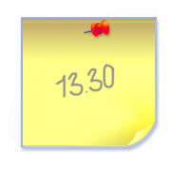 | COUNTING TAPE – SIMPLIFIED FRACTION  

