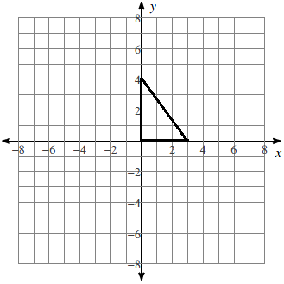
The triangle below is revolved about the y-axis.

A) Draw and name the three-dimensional figure that is created by revolving the triangle about the y-axis.

B) What formula would you use to find the surface area of the three-dimensional figure?
C) What is the surface area of the three-dimensional figure? (Leave $π$ in your answer)

D) What formula would you use to find the volume of the three-dimensional figure?
E) What is the volume of the three-dimensional figure?

The rectangle below is revolved about the y-axis.
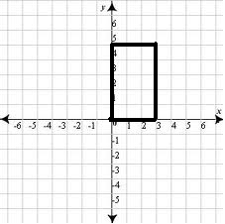
A) Draw and name the three-dimensional figure that is created by revolving the triangle about the y-axis.

B) What formula would you use to find the surface area of the three-dimensional figure?
C) What is the surface area of the three-dimensional figure? (Leave $π$ in your answer)

D) What formula would you use to find the volume of the three-dimensional figure?
E) What is the volume of the three-dimensional figure?

The rectangle below is revolved about the y-axis.
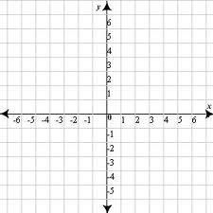
A) Draw and name the three-dimensional figure that is created by revolving the triangle about the y-axis.

B) What formula would you use to find the surface area of the three-dimensional figure?
C) What is the surface area of the three-dimensional figure? (Leave $π$ in your answer)

D) What formula would you use to find the volume of the three-dimensional figure?
E) What is the volume of the three-dimensional figure?

