Adv. Algebra 2 – Learning Target Sheets (Topic Overview)
Topic 1: Linear Functions and Systems

 | 8/18(A) or 8/21(B)  1-0 Interval Notation, Key Features of Functions  How can I use mathematical symbols to represent groups of numbers? | Assignment
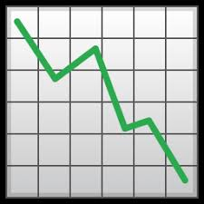 | 8/22(A) or 8/23(B)  1-1 Key Features of Functions (continued)  How can I describe the way a function looks using correct vocabulary and notation? | Assignment  12- 16, 20-22, 25, 27, 30- 33
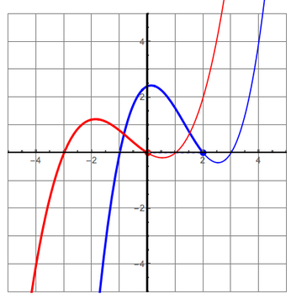 | 8/24(A) or 8/25(B)  1-2 Transformations of Functions  How do changes in an equation affect the shape of a graph? | Assignment
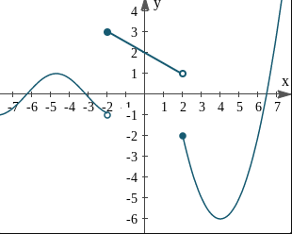 | 8/28(A) or 8/29(B)  1-3 Piecewise Functions  How can I evaluate and graph a piecewise function? | Assignment
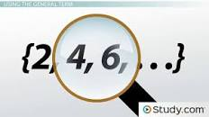 | 8/30(A) or 8/31(B)  1-4 Arithmetic Sequences and Series | Assignment
 | 9/1(A) or 9/5(B) Review for Quiz
 | 9/6 (A) or 9/7 (B)  Topic 1 Quiz and  1-5 Solving Equations/Inequalities by Graphing
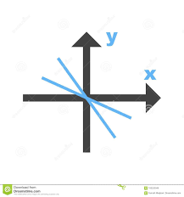 | 9/8(A) or 9/11(B)  1.6 Solving Systems of Equations by Substitution, Graphing, Elimination
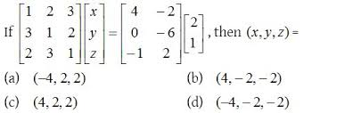 | 9/12(A) or 9/13(B)  1.6/1.7 Solving Systems of Equations with Matrices
9/14(A) or 9/15(B)
Topic 1 Review
9/18(A) or 9/19(B)
Topic 1 Test
*These assignments are subject to change.*

