 | Linear | Exponential | Quadratic
EQUATION
WORDS
TABLE | 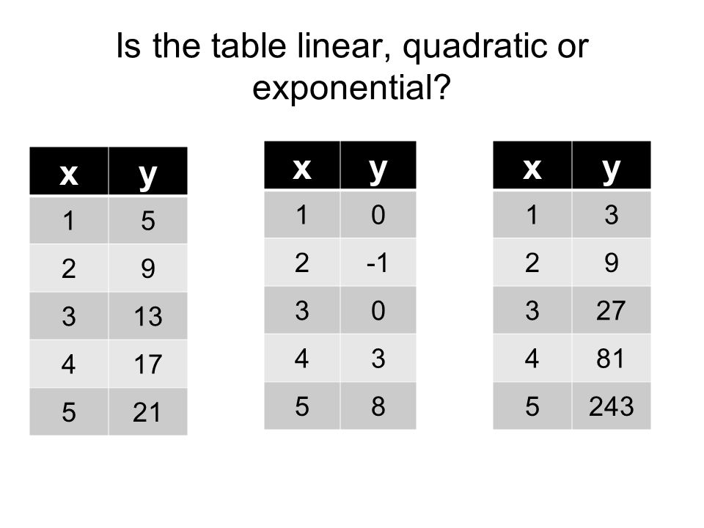
GRAPH | 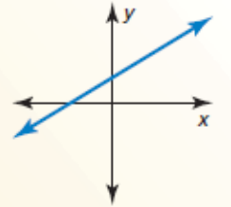 | 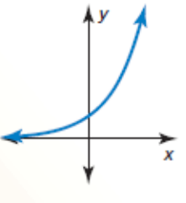 | 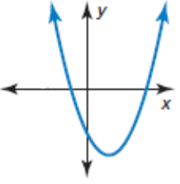

Linear | Exponential | Quadratic

