Geometry Common Assessment #3 Review Name _________________________________

- If $AC=38$, what is the value of $x$?
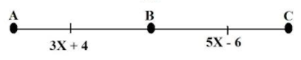

- Line $p$ intersects lines $a and b$. If $a∥b$, by which theorem is $∠3≅∠6$?
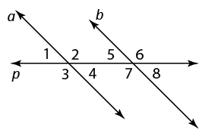
- Alternate Exterior Angles Theorem
- Alternate Interior Angles Theorem
- Corresponding Exterior Angles Theorem

- What is the hypothesis of the conditional statement: If two angles are vertical angles, then they are congruent.

- Fill in the blanks: Parallel lines are in the same ___________________, but they do not ____________________.
angle translate
figure intersect
plane correspond
reflection reflect

- What is $m∠ABD$?
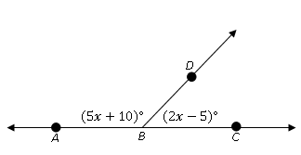

- What is the value of $x$?
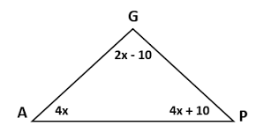

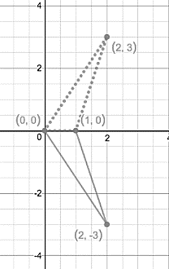
- What rigid motion transformation maps the solid line figure onto the dotted line figure?
  - Reflection
  - Rotation
  - Translation

- What is $m∠QPR?$
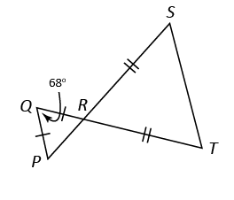

- To show that $∆JKL≅∆LMJ$ by AAS, what must be the value of $x$?
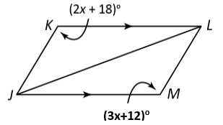

- By which theorem can you conclude $∆VRS≅∆VRK$?
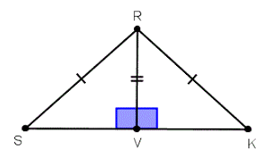
  - AAS
  - SAS
  - SSS
  - HL

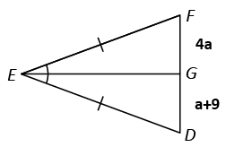
- What is the length of $DF$? (Hint: Solve for $a$, then plug in to $FG and DG$)

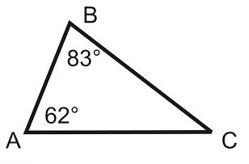
- List the sides of $∆ABC$ from SHORTEST to LONGEST. (Hint: Find $m∠C$ first!)
  - $\overline{AC}, \overline{BC}, \overline{AB}$
  - $\overline{AB}, \overline{BC}, \overline{AC}$
  - $\overline{BC}, \overline{AC}, \overline{AB}$
  - $\overline{AB}, \overline{AC}, \overline{BC}$

- A triangle has two sides with lengths of 20cm and 42cm. Which best describes the length of the third side?
  - Less than 22cm
  - Greater than 62cm
  - Less than 22cm or greater than 62cm
  - Greater than 22cm and less than 62cm

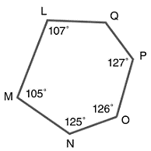
- What is the value of $a$? (Hint: First find the sum of the interior angles of the polygon.)

- What is the measure of one interior angle of a regular 18-gon? (Hint: first find the sum of the interior angles.)

- What is the perimeter of $∆XYZ$?
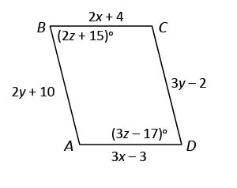
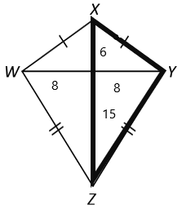

- What must the values of $x and y$ be for $ABCD$ to be a parallelogram?

$x=____________$; $y=______________$

- Which statements are properties of rectangles?
  - Diagonals are perpendicular. Yes No
  - Diagonals are congruent. Yes No
  - Diagonals bisect opposite angles. Yes No
  - All four sides are congruent. Yes No
  - Opposite sides are congruent. Yes No

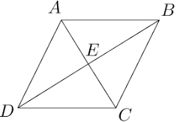
- Which additional piece of information would show that parallelogram $ABCD$ is a rhombus?
  - $\overline{AE}≅\overline{EC}$
  - $\overline{AD}∥\overline{BC}$
  - $\overline{AC}⊥\overline{BD}$
  - $\overline{AB}≅\overline{DC}$

- Which is the most precise description of the quadrilateral?
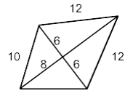
  - Kite
  - Parallelogram
  - Rectangle
  - Rhombus

