Grade 6 Topic 5 Online Assessment (question print out)
Name: _____________________________
1.
A preschool has a student to teacher ratio of 5:2. Which of the following ratios is equivalent to this ratio?
A. 45 teachers to 18 students
B. 45 students to 18 teachers
C. 35 students to 10 teachers
D. 10 students to 7 teachers

2.
José is using 12 brown tiles and 8 white tiles to design a section of an outdoor patio. Which ratio compares the number of brown tiles to the total number of tiles in one section?
- 12:8
- 8:12
- 12:20
- 8:20

3.
The table shows the party affiliation of the 100 senators of the 109th Congress. The ratio of Republicans to Democrats is 5:4. How many senators are Democrats? Independents?
Complete the table. Enter your answers in the boxes.
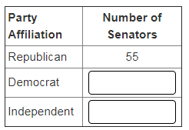

4.
An animal shelter has a ratio of cats to dogs that is 9:7.
Part A
If the shelter only houses dogs and cats, what is the ratio of dogs to total animals?
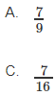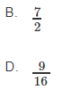

Part B
A second shelter has a ratio of cats to dogs of 6 to 5. If both shelters have 18 cats, which shelter has more dogs?
Use the drop-down menu to show your answer.

first
second

5.
Part A
Complete the ratio table. Enter your answers in the boxes.
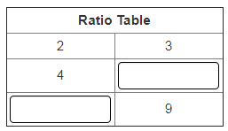
Part B
Choose the graph that shows the pairs of values from Part A.
A.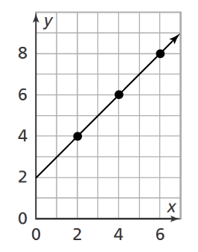 B. 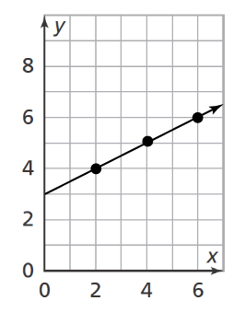
C. 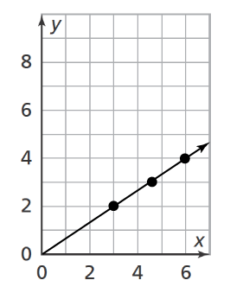 D. 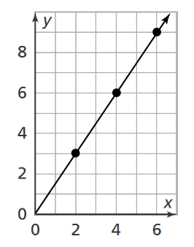
6.
If Mrs. Banks made 44 quarts of jelly, how many gallons did she make?

A. 11 gallons
B. 22 gallons
C. 88 gallons
D. 176 gallons

7.
In 1 hour, 32 cars pass through a particular intersection. At the same rate, how long would it take for 96 cars to pass through the intersection?

- 2 hours
- 3 hours
- 8 hours
- 16 hours

8.
How many milliliters of liquid are in the container shown below? Enter your answer in the box.
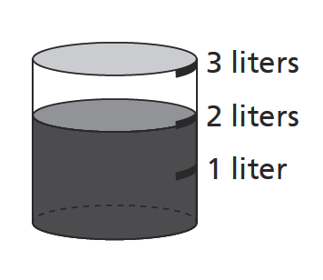


9.
A loaf of bread weighs about 1 pound. Choose all of the metric measures that are less than 1 pound.

A. 1 kg
B. 0.5 kg
C. 500 g
D. 450 g
E. 100 g

10.
April can buy a package of 10 folders for $1.20 or a package of 8 folders for $1.12. What is the unit price, per folder, in each package?

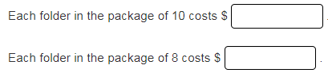

11.
Jessica is buying several bunches of bananas to make desserts for a fundraiser. She can buy 10 pounds of bananas for $14.90 or 8 pounds of bananas for $12.08.
Part A
How much does each pound of bananas cost in each case?
Drag the tile with the cost of each pound to the correct box.
Each tile may be used once or not at all.
Cost of Each Pound
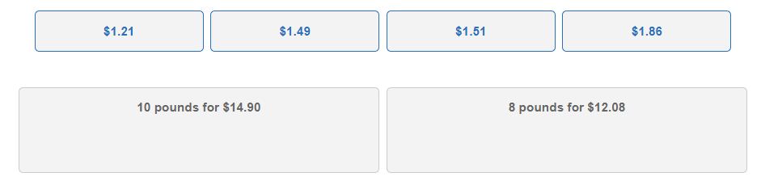

Part B
Use the information in Part A to choose the better buy.
Use the drop-down menus to explain your answer.

10 pounds
8 pounds
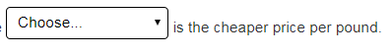
$1.21
$1.51
$1.86
$1.49

