12-3 Permutations and Combinations

I can use permutations and combinations to find the number of outcomes in a probability experiment.

Essential Question: How are permutations and combinations useful when finding probabilities.

Example 1 Use the Fundamental Counting Principal
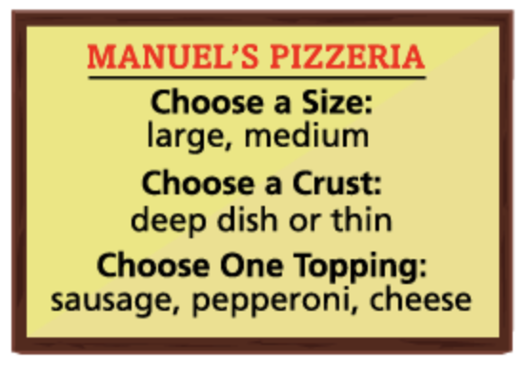
Manuel wants to advertise the number of one-topping pizzas he offers to his customers. How many different one-topping pizzas are available at Manuel’s Pizzeria?

This example illustrates the _______________________________________________________________________________. If there are m ways to make the first selection and n ways to make the second selection, then there are $m×n$ ways to make the two selections. If a third selection, p, is added, then there are $m×n×p$ to make all three selections, and so on.

Example 2 Find the Number of Permutations
- Gabriela is making a playlist with her 3 favorite songs. How many possible orders are there for the songs?

The ________________________________ of a positive integer n is the product of all positive integers less than or equal to n. By definition: 0!= ________

- Gabriela wants to make another playlist with 5 of her favorite artist’s 8 most popular songs. How many different playlists are possible?

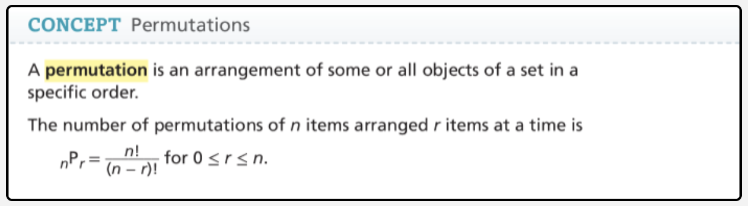
Example 3 Find the Number of Combinations

Marisol is planning to be a counselor at summer camp. She can choose 3 activities for her session. How many different combinations of 3 activities are possible?

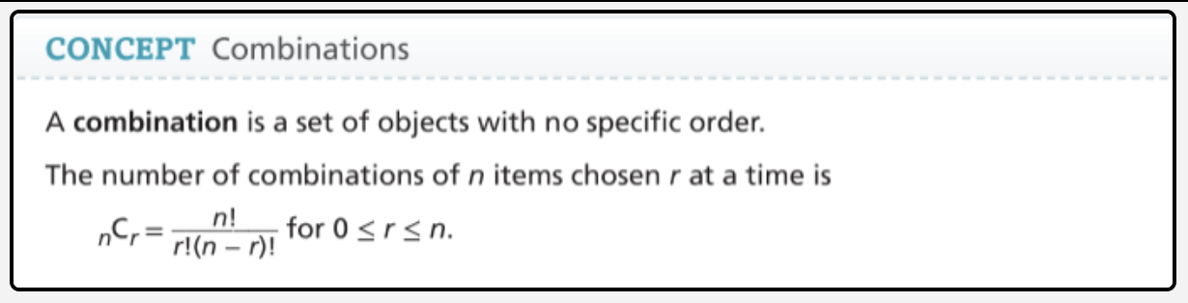
Example 4 Use Permutations and Combinations to Find Probabilities
A teacher chooses 5 students from the names shown at random to work together on a group project. What is the probability that the 5 students are all boys ?


