12-2 Conditional Probability
I can find the probability of an event given that another event has occurred.

Essential Question: How are conditional probability and independence related in real-world experiments?

Example 1 Understand Conditional Probability
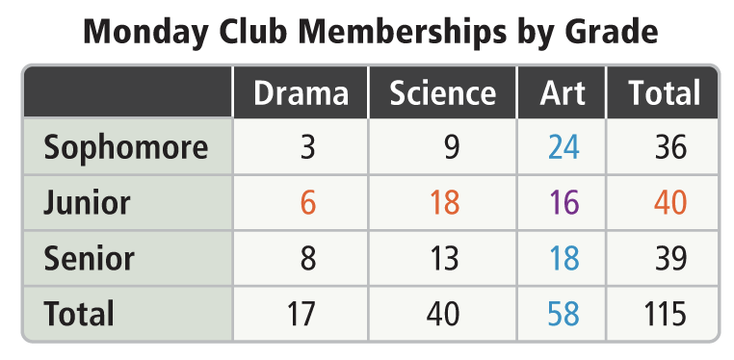
A student committee is being formed to decide how after-school activities will be funded. The committee members are selected at random from current club members. The frequency table shows the current club membership data.

What is the probability that a member of the art club selected at random is a junior?

The probability that an event B will occur given that another event A has already occurred is called a _____________________________ probability is written as $P(B|A)$.

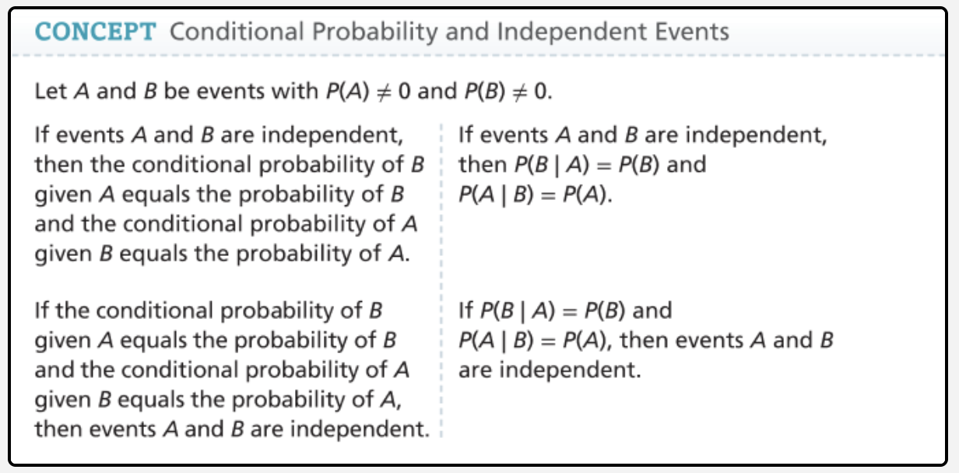

Example 2 Use the Test for Independence
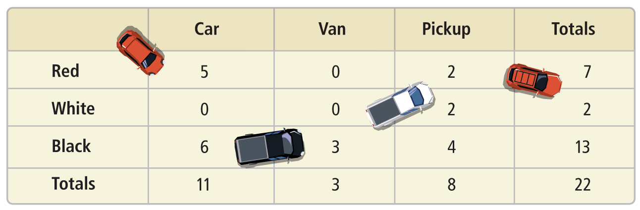
The table below shows the vehicles in a parking garage one afternoon. A vehicle in the garage will be selected at random. Let B represent “the vehicle is black” and V represent “the vehicle is a van”. Are the events B and V independent or dependent?

Since $P\left(V | B\right)_____________$ B and V are not independent events, that are ___________________________ events.

Example 3 Apply the Conditional Probability Formula
A band’s marketing agent conducted a survey to determine how many high school fans the band has. What is the probability that a surveyed student plans to attend and is a fan of the group?
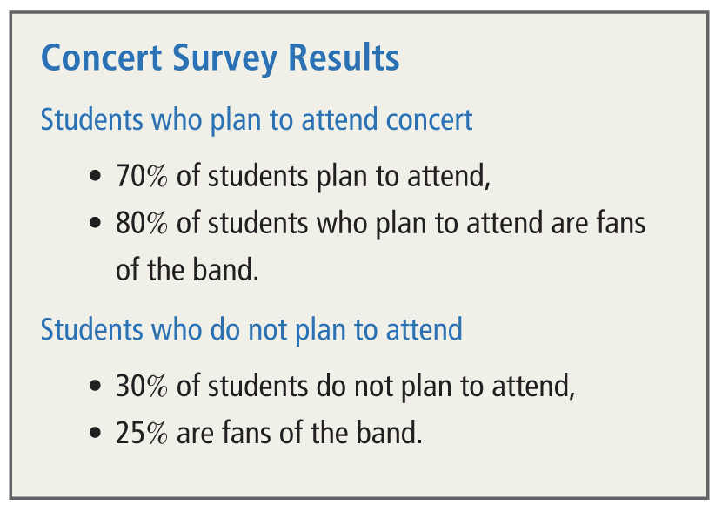
Example 4 Use Conditional Probability to Make a Decision
A marketer is looking at mobile phone statistics to help plan an online advertising campaign. She wants to find which product is most likely to be purchased after a related search.


