Example 4 Find the probabilities of Independent Events
Alex cannot decide which shirt to wear today, so she chooses one at random.

The probability of rain today is 40%, or $\frac{2}{5}$.
- What is the probability that Alex chooses a yellow shirt and it does not rain today?

- What is the probability that Alex chooses a yellow shirt and it does not rain today or that Alex chooses a green shirt and it rains today?

12-1 Probability Events

I can use relationships among events to find probabilities.

Essential Question: How does describing events as mutually exclusive or independent affect how you find probabilities?

Example 1: Find the Probabilities of Mutually Exclusive Events
You roll a standard number cube once. Let E represent the event “roll an even number”. Let T represent the event “roll a 3 or 5”.
A. What is the probability that you roll an even number or roll a 3 or 5?
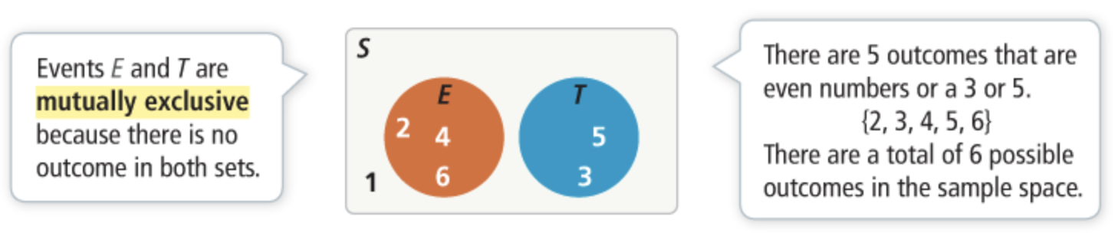

B. You roll a standard number cube once. What is the probability that you roll an even number and a 3 or 5?

C. You roll a standard number cube once. What is the probability that you do not roll an even number?

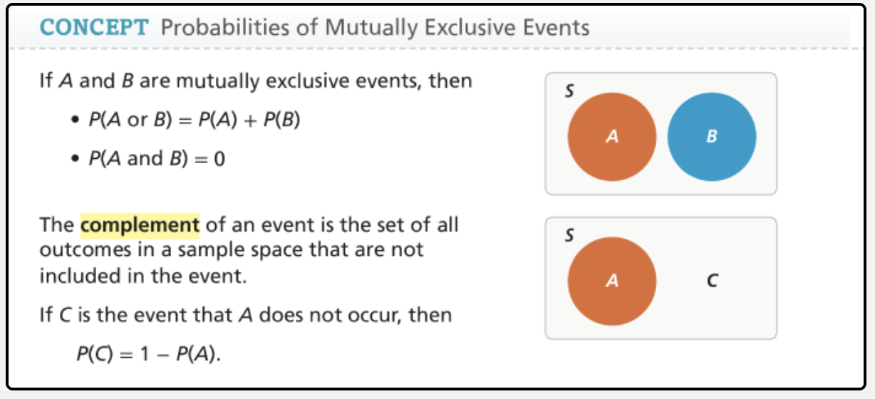
B. A marble is chosen at random from the jar and not replaced. Another marble is chosen at random from the jar. Does the color of the first marble chosen affect the possible outcomes for the second marble chosen?

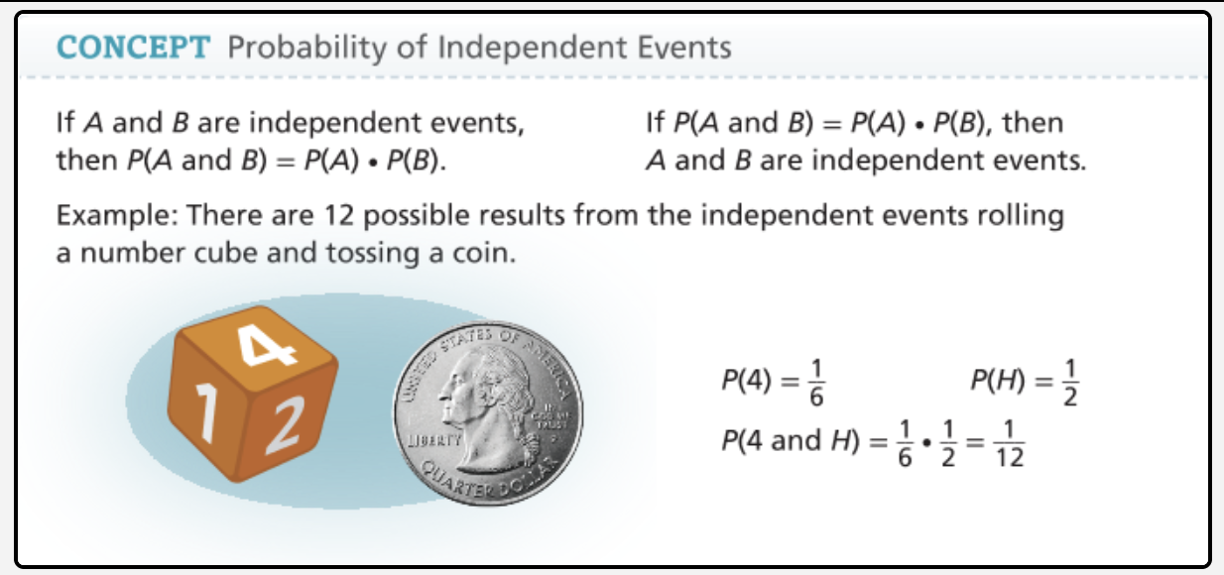

Example 2: Find the Probability of Non-Mutually Exclusive Events
A student-made target includes two overlapping squares. Assume that a sticky ball thrown at a target is equally likely to land anywhere on the target. What is the probability that the ball lands inside one or both of the squares?
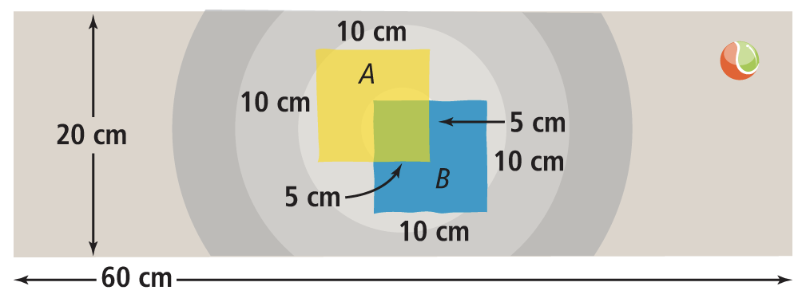

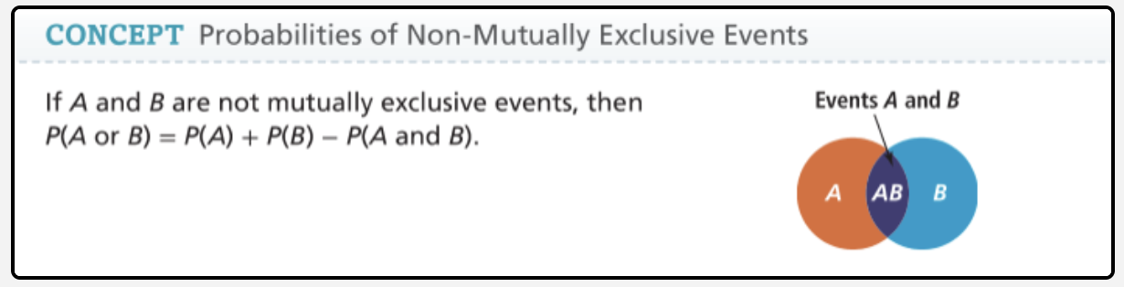
Example 3 Identify Independent Events
A jar contains 12 green marbles and 8 violet marbles.
A. A marble is chosen at random from the jar and replaced. Another marble is chosen at random from the jar. Does the color of the first marble chosen affect the possible outcomes for the second marble chosen?

Two events are _______________________________________ events if and only if the occurrence of one event does not affect the probability of a second event.



