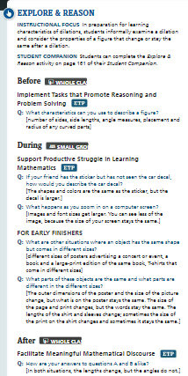
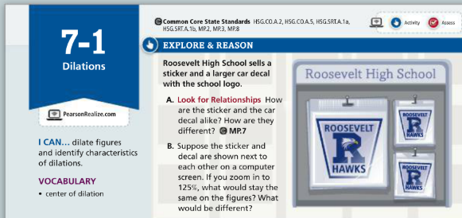

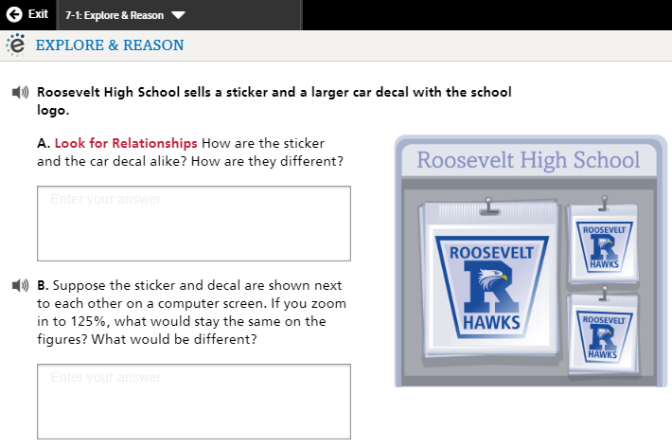

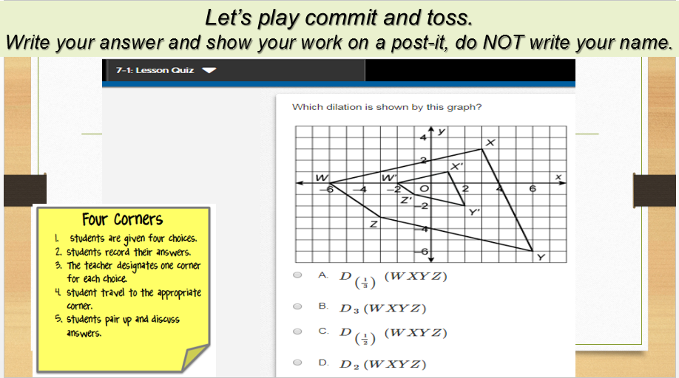

Geometry 7-1 Use these cards to play Showdown or Quiz, Quiz, Trade
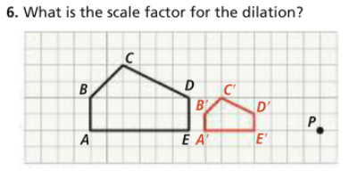 | 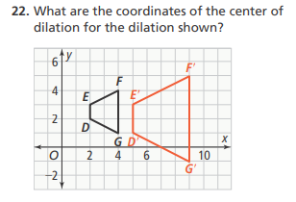
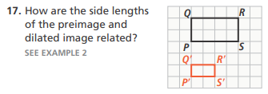 | 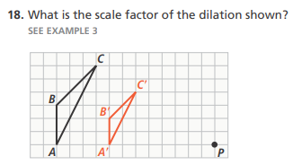
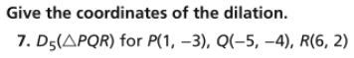

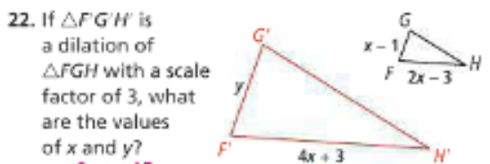 | 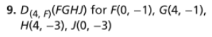
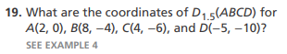 | 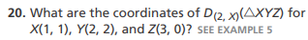
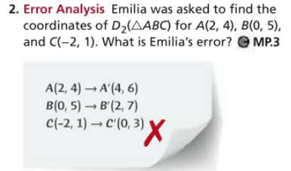 | 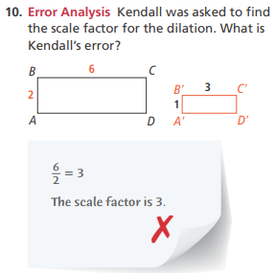
Geometry 7-1 Pass the problem –
Work with your group to complete the first problem, then pass the paper to the next group give feedback on the first group’s work, then complete the next problem, then pass the paper to the next group give feedback on the first two group’s work, then complete the next problem, continue until you get your paper back with all 4 problems complete with feedback. Check over the final work as a group and decide if the problems are ready to turn in.
 | 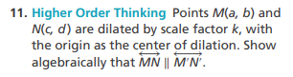
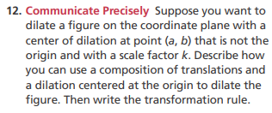 | 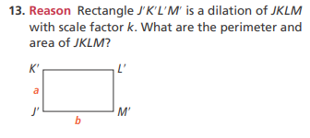

Geometry 7-1 Pass the Problem –
Do the first problem, then pass the problem to the next person to check the first person’s work then do the next problem, continue until all problems have been checked and are complete.
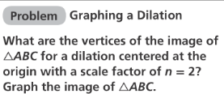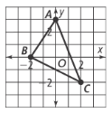  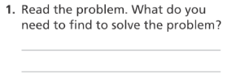 | 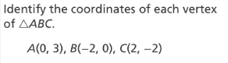  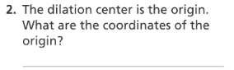  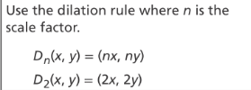  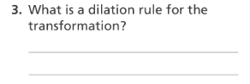
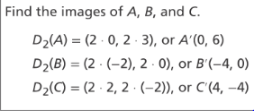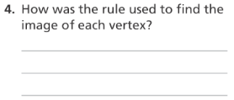 | 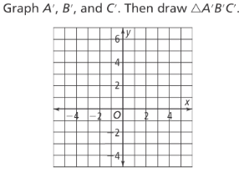  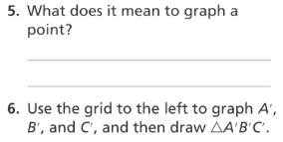

Mathematical Literacy and Vocabulary Sheet Leeson 7-1

Geometry 7-1 Rally Coach
Partner A is: _________________________ Partner B is: _________________________

Partner A Solves, Partner B Coaches | Partner B Solves, Partner A Coaches

Geometry 7-1 Numbered Heads Together or Think, Pair Share….
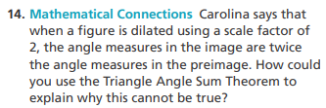 | 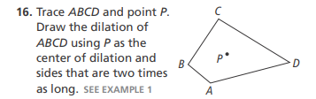
 | 

