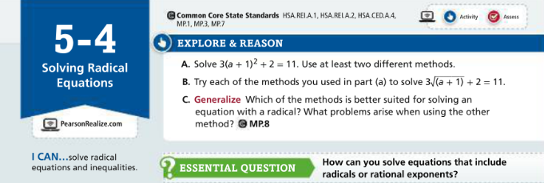

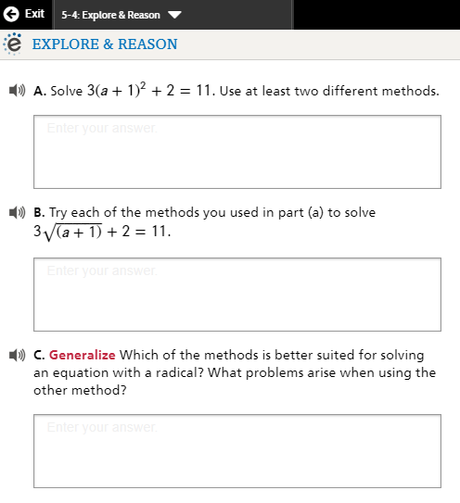

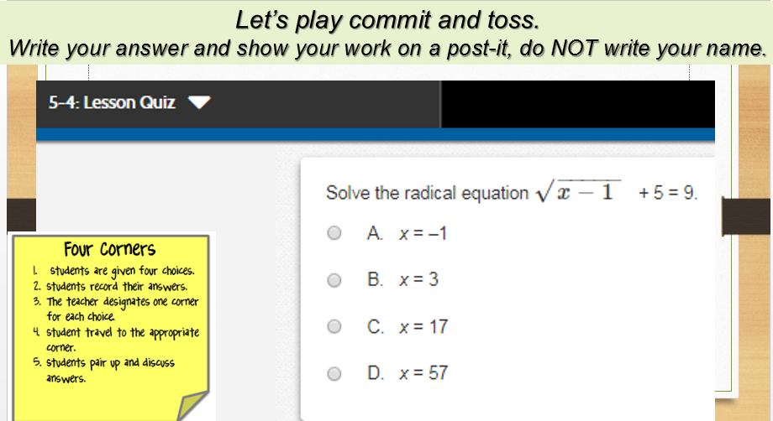

Algebra II Lesson 5-4: Use these cards to play Showdown or Quiz, Quiz, Trade

 | 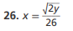
 | 


 | 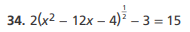


Algebra II Pass the problem –
Work with your group to complete the first problem, then pass the paper to the next group give feedback on the first group’s work, then complete the next problem, then pass the paper to the next group give feedback on the first two group’s work, then complete the next problem, continue until you get your paper back with all 4 problems complete with feedback. Check over the final work as a group and decide if the problems are ready to turn in.
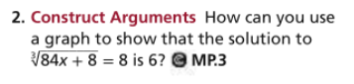 | 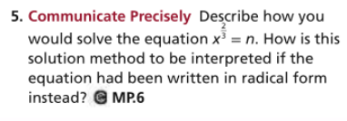
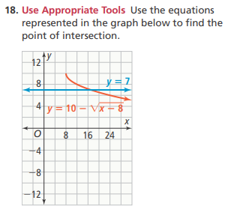 | 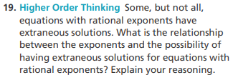

Algebra II Lesson 5-4: Pass the Problem –
Do the first part of the problem, then pass the problem to the next person to check the first person’s work then do the next part of the problem, continue until all parts of the problem have been checked and are complete.
Part 1  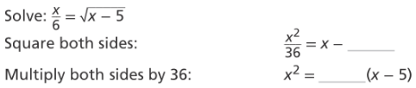 | Part 2  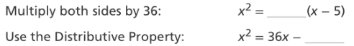
Part 3  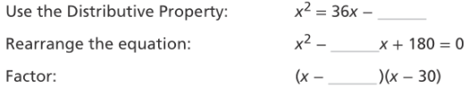 | Part 4  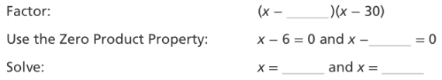

Algebra II Lesson 5-4 Reteach to Build Understanding

Algebra II Lesson 5-4 Rally Coach
Partner A is: _________________________ Partner B is: _________________________

Partner A Solves, Partner B Coaches | Partner B Solves, Partner A Coaches
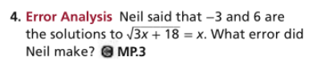 | 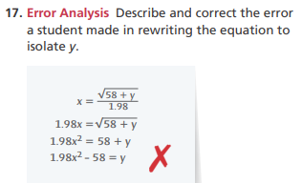
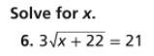

Algebra II Lesson 5-4 Numbered Heads Together or Think, Pair Share….
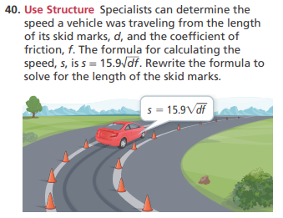 | 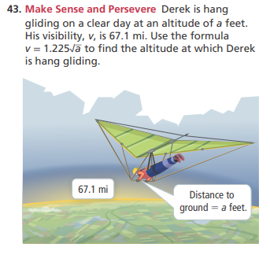
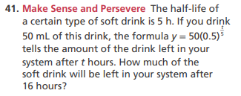 | 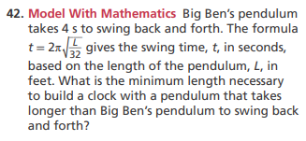

Cut cards apart and:
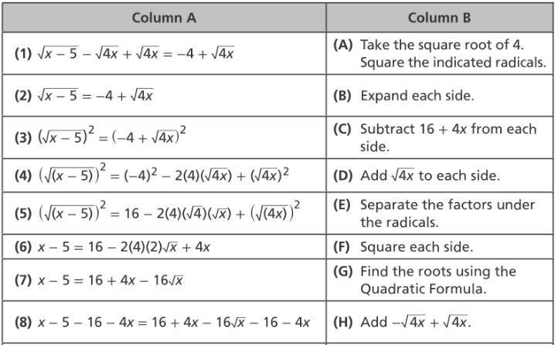
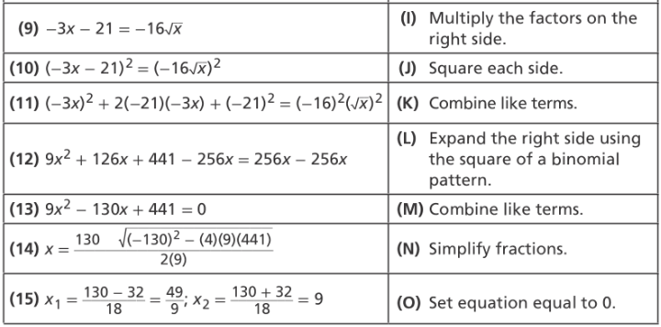
Algebra II Lesson 5-4 Mathematical Literacy and Vocabulary


