enVision Geometry Topic 5 Warm Up Name:_____________________________
 | Ex: 1 | Ex: 2 | Ex: 3 | Ex: 4
5-1 | What is the value of AD?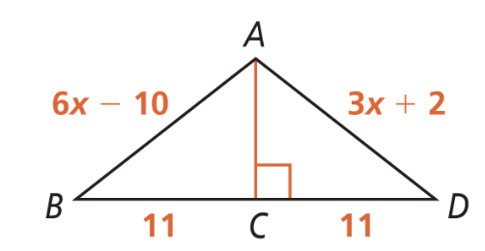 | What is the value of WY? 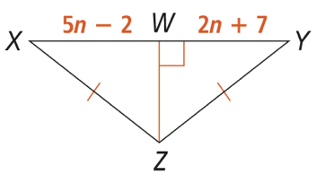 | What is the value of OL? 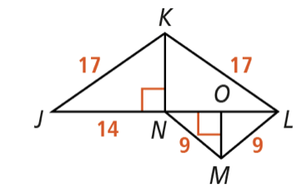 | How are the two triangles related? 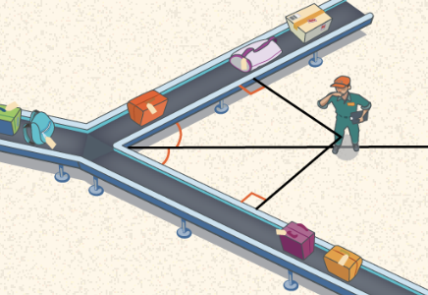
5-3 | What are the altitude and median of the given triangle? 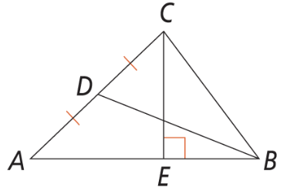 | Find AD for the triangle: 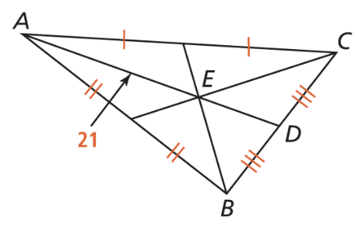 | Find AD for the triangle: 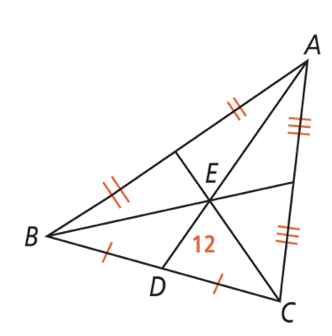 | Find the lengths of each of the triangles medians: 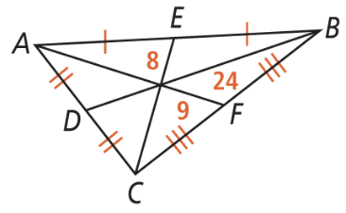
5-4 | Which angle measure appears to be the smallest. How is it related to the side lengths. 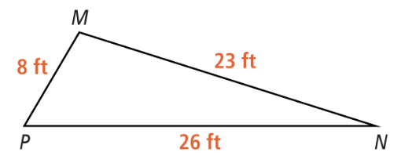 | Put the angles in order from smallest to largest. 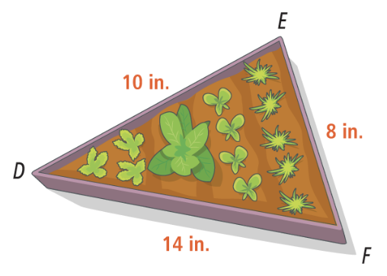 | Put the sides in order from largest to smallest. 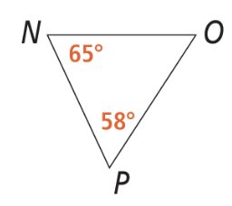 | What are possible lengths of the third side 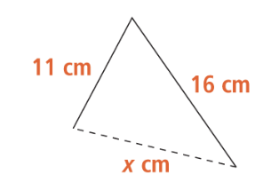  Could a triangles have side lengths 16, 39, 28?
5-5 | For the triangles.  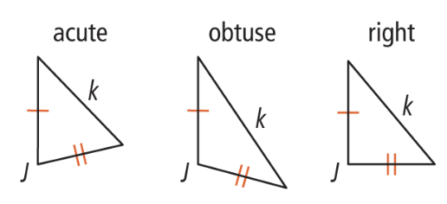 | What are the possible values for x for the diagram. 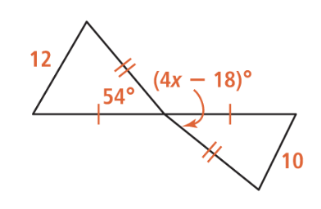 | What are the possible values for x for the diagram. 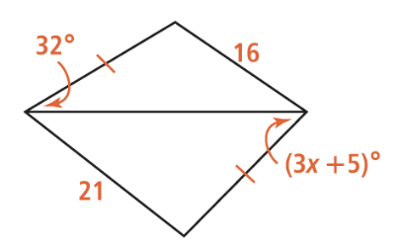 | Order AB, BC, CD from least to greatest.  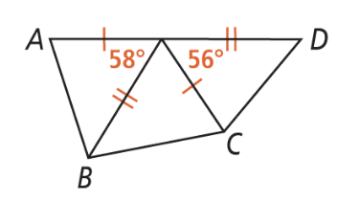
ACT | 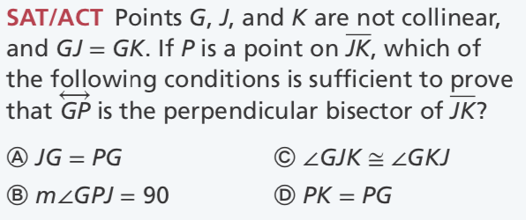 | 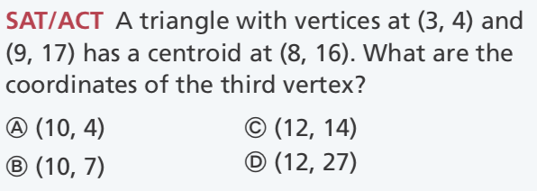 | 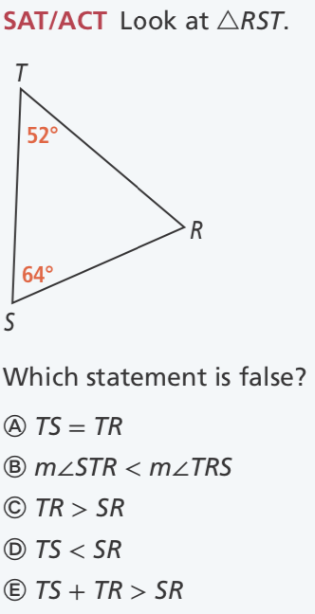 | 

