Geometry enVision Topic 4 Warm Up Name:_____________________________
 | Ex: 1 | Ex: 2 | Ex: 3 | Ex: 4
4-1 |  | 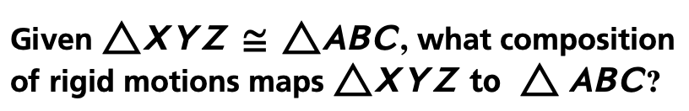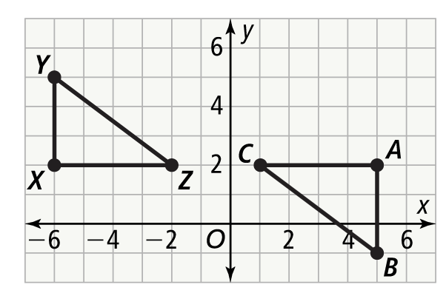 | Are these figures congruent? | Are these figures congruent? 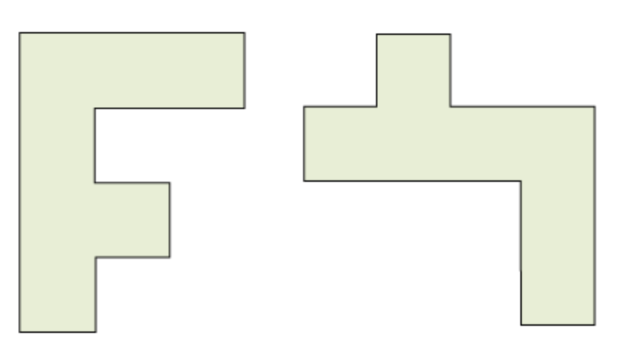
4-2 | What is the value of x? 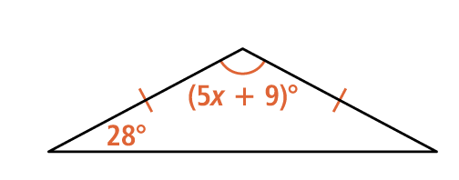 | What are the lengths of the three sides?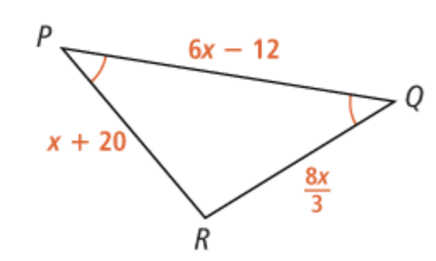 | 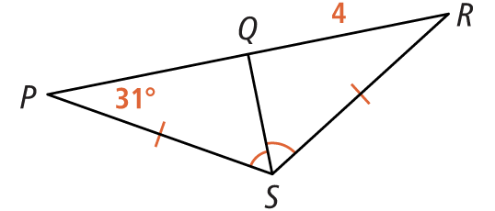 | 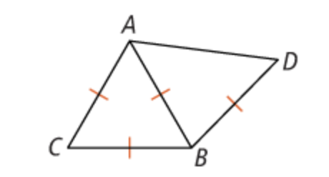
4-3/  4-4 | What is the relationship between the triangles?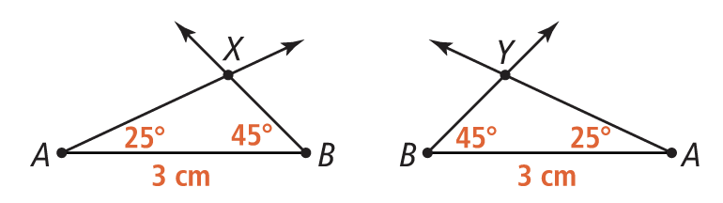 | Are any fo the triangles congruent? Explain?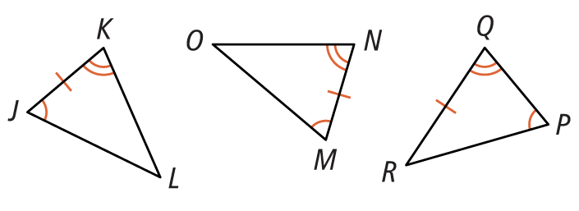 | What additional information is needed to prove these triangles are congruent by ASA? AAS?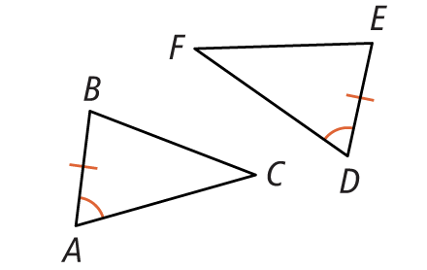 | What is the value of x? 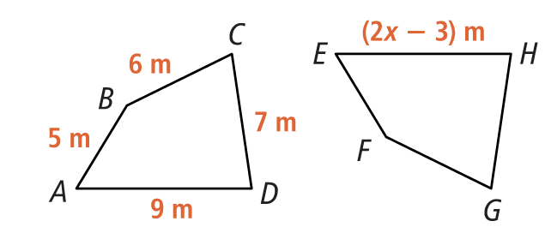
4-5 | Can you show that two right triangles are congruent when any one pair of corresponding acute angles is congruent, and any one pair of corresponding legs is congruent? Explain. | What information is needed to apply HL theorem? 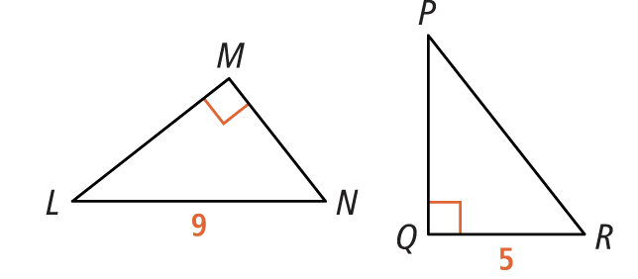 | What information would be sufficient to show the two triangles are congruent by the Hypotenuse-Leg (HL) Theorem?  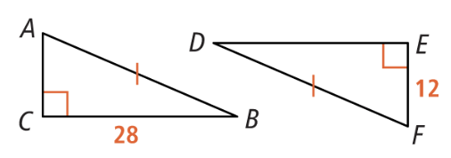 | What information would be sufficient to show the two triangles are congruent by the Hypotenuse-Leg (HL) Theorem?  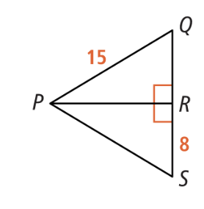
4-6 | 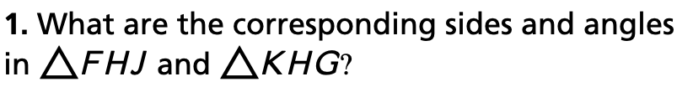  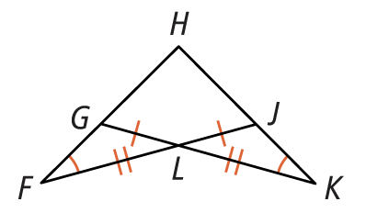 | 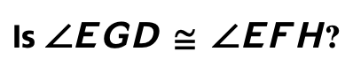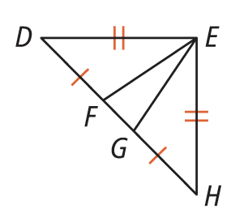 |   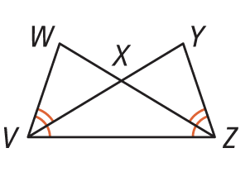
ACT | 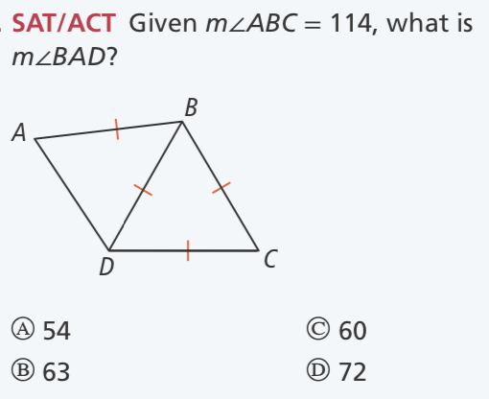 | 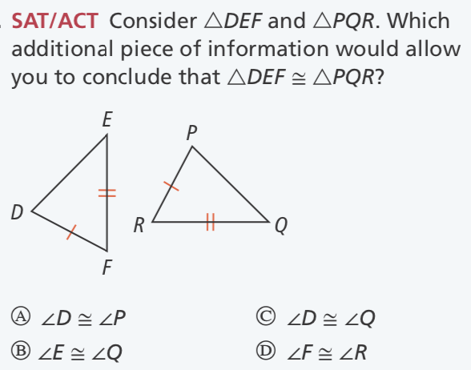 | 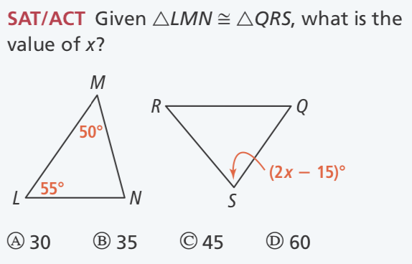 | 

