Geometry/ Adv Geom Topic 1 Warm Up Name:_____________________________
Date | Ex: 1 | Ex: 2 | Ex: 3
1-1 | Refer to the figure shown. How can you find the length of AC ? | What is JK? What is KM? | Points J, K, and L are collinear. If JL = 25, what is n? What is JK? KL?
1-3 | Find the midpoint for the given endpoints. C(-2, 5) and D(8,-12) | Can the following equation be used to find the distance between two points? Explain. | How far does the shortstop need to throw to reach first base? | Find the distance between the two endpoints.  C(-2, 5) and D(8,-12)
1-5 | Write the following statement as a conditional: A triangle with all angles congruent is equiangular. | What does the following symbol stand for: ~ | Write the converse of the conditional statement:  If a polygon is a quadrilateral, then it has four sides. | Write the converse, the inverse and the contra positive: If today is a weekend day, then tomorrow is a Monday.
1-6 |  |  | Using the Law of Syllogism, draw a conclusion:  If it is a holiday, then you don’t have to go to school. If it is Labor Day, then it is a holiday. | Using the Law of Detachment, draw a conclusion:  Martin walks his dog before dinner every day. Martin is now eating his dinner.
1-7 | Find the value of x and each measured angle. | Find the value of x and each measured angle. 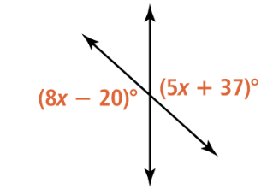 | If ∠𝟤angle 2 and ∠𝟥angle 3 are complementary, how could you use the Vertical Angles Theorem to find 𝘮∠𝟣?  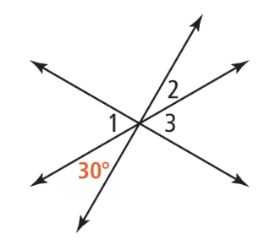 | The Leaning Tower of Pisa leans at an angle of about 𝟦° from the vertical, as shown. Find the value of x.  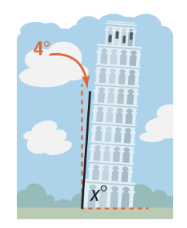
ACT | 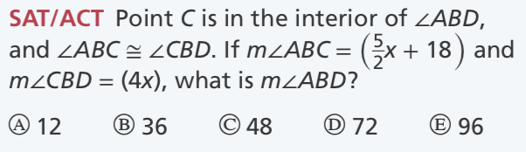 | 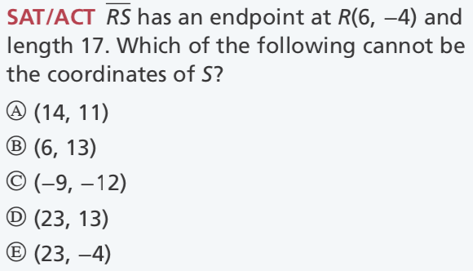 | 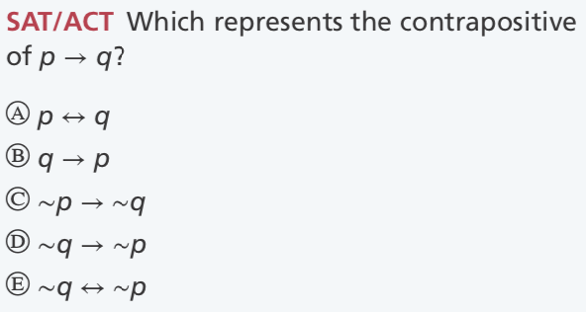 | 

