Are the expressions equivalent? Show and explain each set on your whiteboard. (from 6th grade Lesson 3-3 enrichment page)
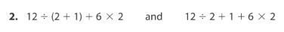

Insert operation signs and grouping symbols to make the numerical expressions on the left equal to the given values.
Use your whiteboard to record your work for each problem. (from 6th grade Lesson 3-3 enrichment page)
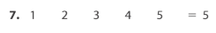

Match the expression with the solution. Use your calculator to help you. (from 6th grade Lesson 3-3 questions 30 & 31)
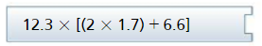 | 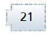
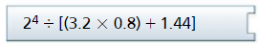 | 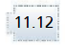
 | 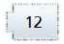
 | 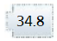
 | 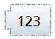
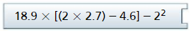 | 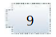
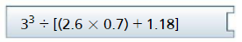 | 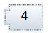
 | 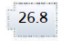
Pass the Problem (from 6th grade Lesson 3-3 question 15)
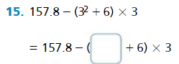 | 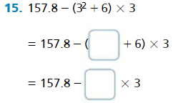
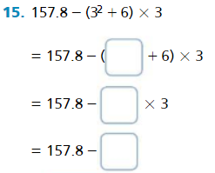 | 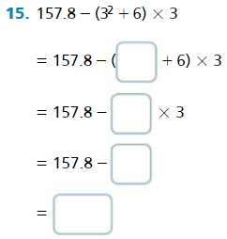

Pass the Problem (from 6th grade Lesson 3-3 question 24)
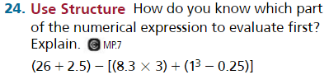  Complete the first step only. |  |  | Copy the first step completed and complete the next step:
Copy the first two steps completed and complete the next step: |  |  | Copy the first three steps completed and complete the next step:
Copy the first four steps completed and complete the next step: |  |  | Copy the first five steps completed and complete the next step:
 | Cut out the pieces below. Sort problems one through six under the correct heading. (from 6th grade Lesson 3-3 vocabulary)
 |  |  | 
 |  | 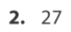 |  | 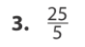
 | 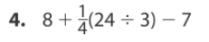 | 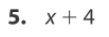 |  | 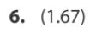

Partner A is: _________________________  Partner B is: _________________________  (from 6th grade Lesson 3-3 questions 20 & 21) | 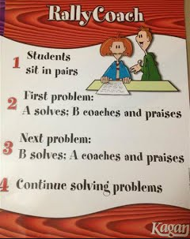
Partner A Solves, Partner B Coaches  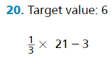 | Partner B Solves, Partner A Coaches  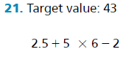

Think, Pair, Share - Gives them the opportunity to think individually about a question and then pair up to share thoughts as a pair. Through sharing out, the teacher is able to determine if students understand the content. | Numbered Heads Together - Each student is assigned a number. Members of group work together to agree on solution. Teacher randomly selects one number. Student with that number answers for the group.
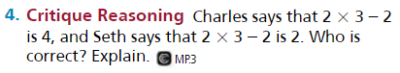  (from 6th grade Lesson 3-3 question 4) | 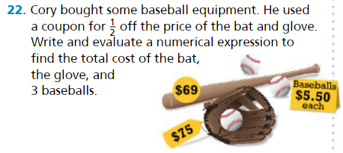  (from 6th grade Lesson 3-3 question 22)

