Use these cards to play Showdown or Quiz, Quiz, Trade
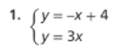 | 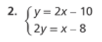
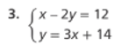 | 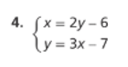
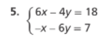 | 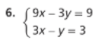
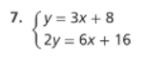 | 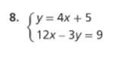
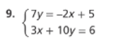 | 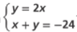
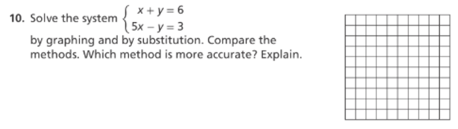
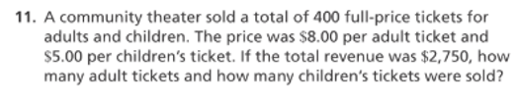

Match the vocabulary concept to the correct example of that concept.

 | 
 | 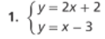
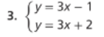 | 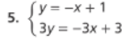
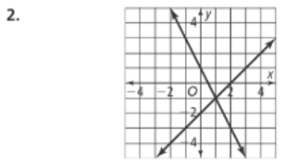 | 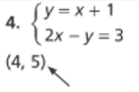

Match the solution description to the correct graph it describes.
 | 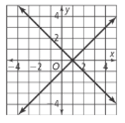
 | 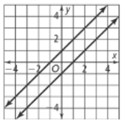
 | 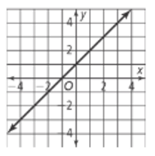
Pass the Problem – Do the first part of the problem in the first box, then pass to the next person to continue the problem in the next box, continue until you get your paper back. Review the steps for correctness and discuss with your group.
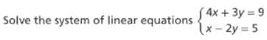   | 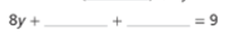
 | 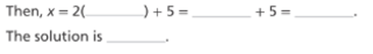

Match the correct solution step to each task.
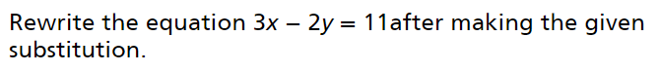
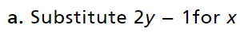

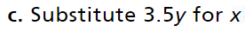

Pass the Problem - work the first problem, after the timer look at what the first person did with the next problem and add to it, after the timer look at what the first two people did with the third problem and add to it, continue until you get your original paper back. Review the work for all four problems and discuss the best solutions for each.
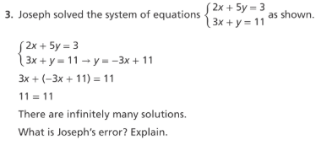 | 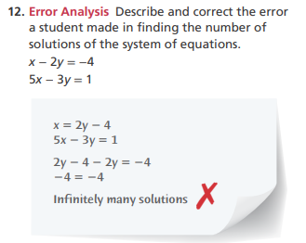
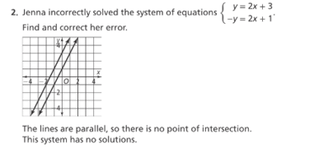 | 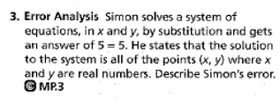
Use Numbered Heads Together Groups to solve each Problem. Be prepared for any number in your group to be called on to explain any solution. Or use Think Pair Share and have students solve on their own, with a partner, then share out.
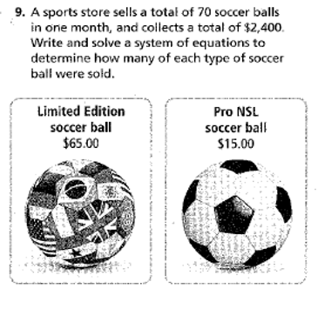 | 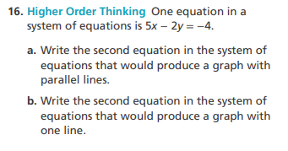
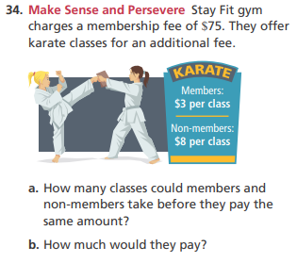 | 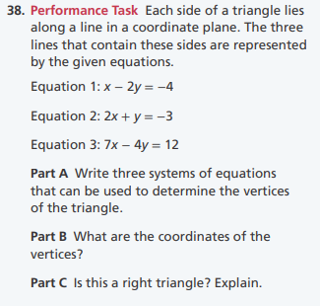

Rally Coach
Partner A is: _________________________ | Partner B is: _________________________
Partner A Solves, Partner B Coaches  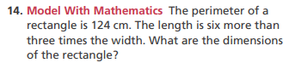 | Partner B Solves, Partner A Coaches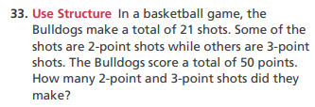
Solve the System  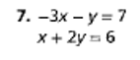 | Solve the System  

