Algebra 1 Topic 3 Warm Up Name:_____________________________
Date | Ex: 1 | Ex: 2 | Ex: 3 | Ex: 4
3-1 | What is the domain and range of the function?  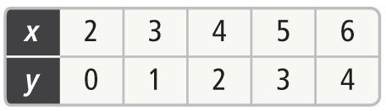  Domain:__________________  Range:___________________ | What is the range of the function?  A car travels 25 miles using 1 gallon of gas. | Is the relation a function? If so, is it one-to-one or not one-to-one?  | Is the relation a function? If so, is it one-to-one or many-to-one? 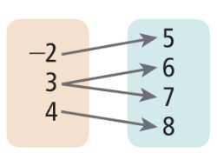
3-2 | What is the value of g(x) = 7x + 15. When x = 4? | What is the value of f(x) = -2x -3  When x = 4? | Write a function for the table:  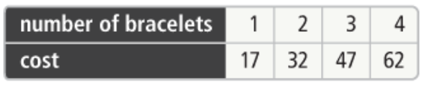 | Graph the function f(x) = -x+1  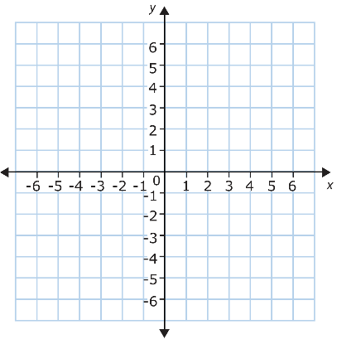
3-4 | Is the following ordered list arithmetic?  26, 39, 52, 65, 78,…. | Write the explicit formula for the given sequence.  12, 19, 26, 33, 40,…. | Write the explicit formula for the table?  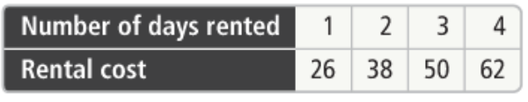 | Using the previous problem, how much would it cost to rent the bicycle for 10 days.
3-5 | What is the relationship shown by the scatter plot? What would the y-int be?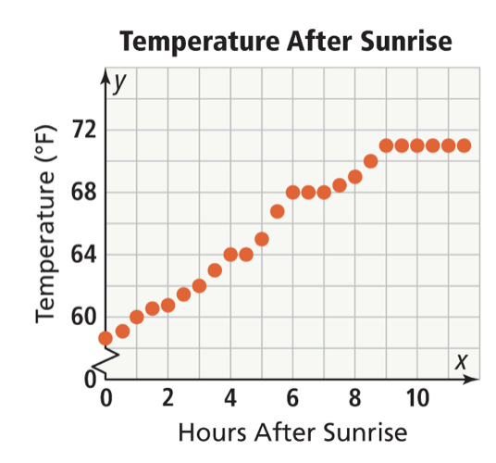 | What is the relationship shown by the scatter plot? What would the y-int be? 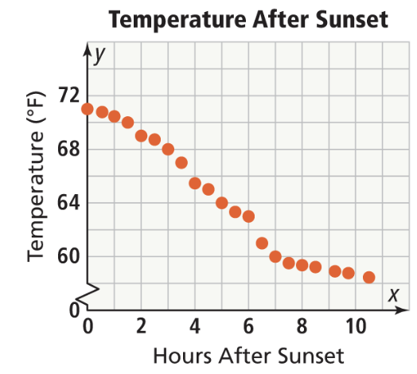 | Write a trend line for the previous scatter plot. (Temperature After Sunset) | Sketch a scatter plot for the given table 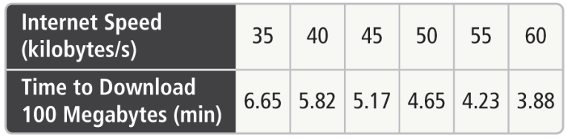
3-6 | Estimate the y-intercept of the given data  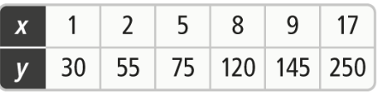 | What does each correlation coefficient tell about the data set:  r = 0.1  r = -0.6 | Using the model y = 47x + 1345, where x is the number of years since 1975, & y is the number of miles flown. Estimate the number of miles flown in 2012. | Can you conclude a positive correlation between ours of sleep and test scores? 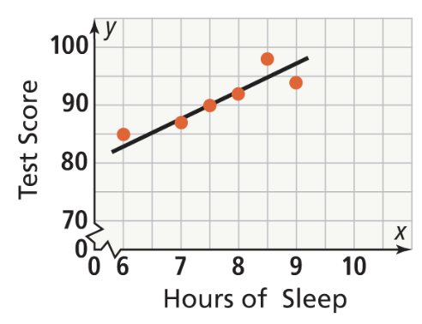
ACT | Given the following equation:  Y = -3x – 5 what is y when x = -2? | If a = 5 and b = 4, evaluate  10b – 4a | Find g(-2) given: 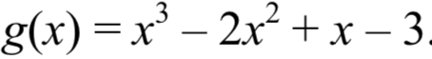 | If Jay trims trees from noon to 6 pm, with the exception of a 30 minute lunch break. Jim can trim 55 trees, How long does it take him to trim one tree?

