Grade 6 Topic 2 Online Assessment (question print out)
Name: _____________________________

1.
What is the opposite value of Emma’s score?
Name | Score
Cassie | –4
Emma | –12
Juanita | 6

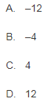

2.
A swimmer dives to 65 feet below the surface of the ocean. Write the integer that represents the depth of the dive.



3.
Which of the following have a value equal to |37|?
Select all that apply.

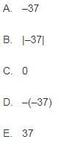

4.
What is the perimeter, in units, of polygon PQRSTU? Enter your answer in the box.
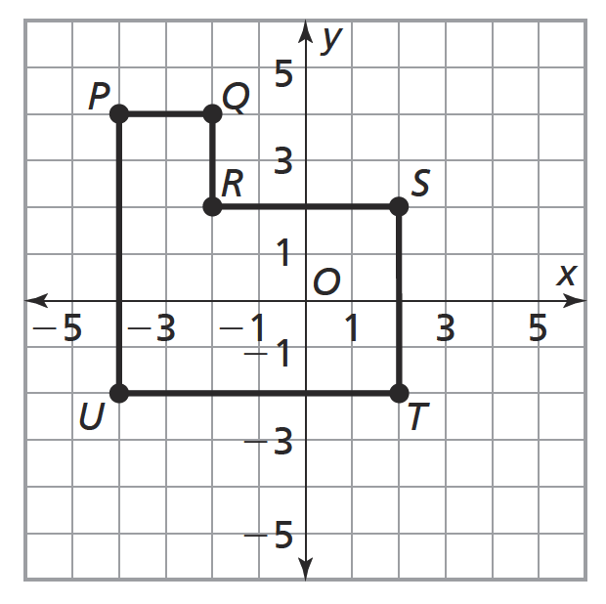

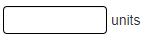

5.
Jeremy listed five rational numbers. Then he drew a number line to display and compare them.
Part A
Plot the numbers on the number line by dragging each one to the correct location.
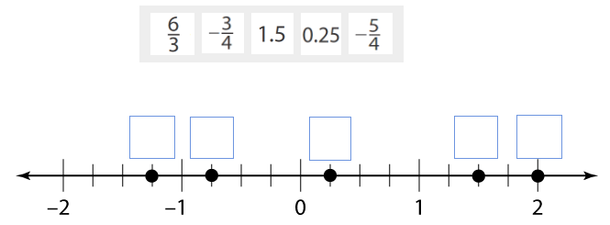
Part B
Choose the inequality that compares the numbers.
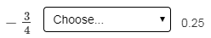
>
<

6.
Which ordered pair locates point P on the coordinate plane?
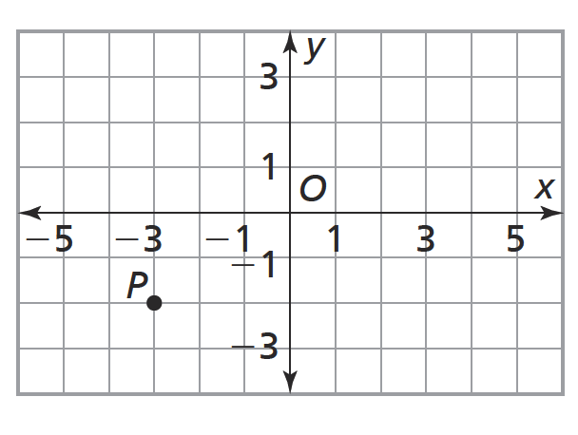

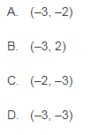

7.
Carlos drew a plan for his garden on a coordinate plane.
Rose bushes are located at A(–5, 4), B(3, 4), and C(3, –5).
Part A
Choose the graph that shows the locations of the rose bushes.
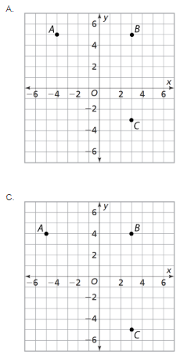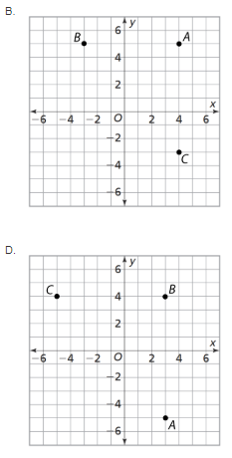

Part B
Use the distance between the rose bushes, which are located at A(−5, 4), B(3, 4), and C(3, –5), to explain where a fourth rose bush should be placed so that it forms a rectangle with the other three bushes.

8.
Enter decimal numbers in the boxes to complete the ordered pair that locates point Q on the coordinate plane.
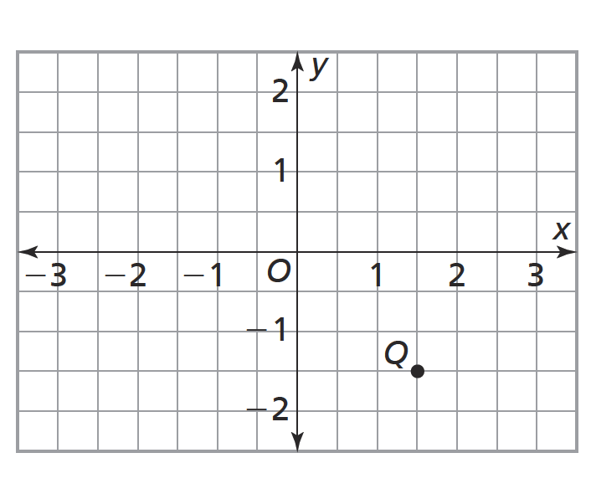


9.
Choose all pairs of points that are reflections of each other across both axes.

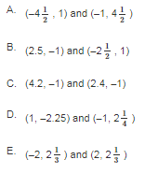

10.
Choose Yes or No to tell whether each statement is correct.
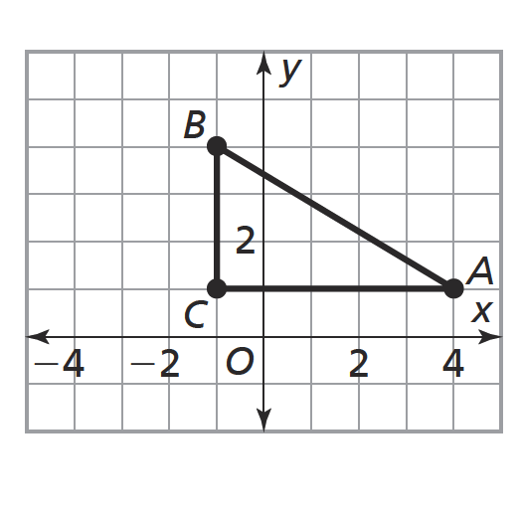
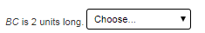
No
Yes
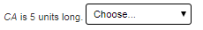
No
Yes
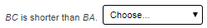
No
Yes
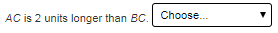
No
Yes

