Geometry – Topic 3 Name:
Transformations Notes Date:
Rigid Motion:

Determine if the following is a rigid motion – justify your answer.
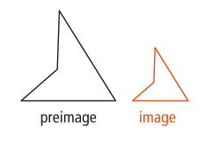
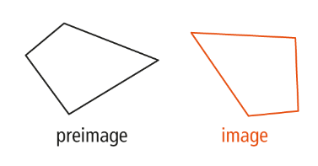
- b.

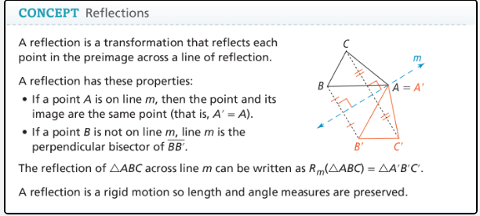
Quadrilateral FGHJ has coordinates F (0, 3), G (2, 4), H (4, 2), J (-2, 0)

Graph $R_{x-axis}(FGHJ)$. Graph $R_{y-axis}(FGHJ)$.
What is the general rule for reflecting What is the general rule for reflecting
a point across the x-axis? a point across the y-axis?
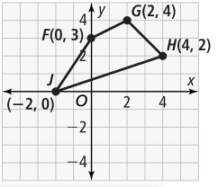

What would be the rule to reflect an image over the line y=x?
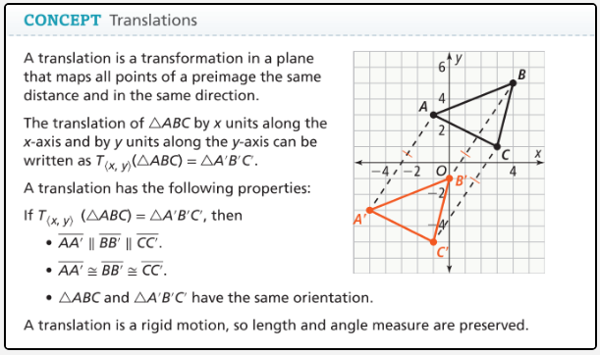

What is the graph of $T_{\left\langle 7,\left.-4\right\rangle \right.}\left(∆EFG\right)=∆E^{'}F^{'}G^{'}?$
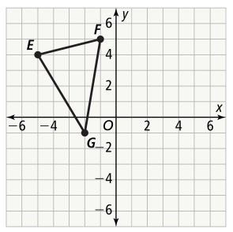
What are the vertices of $∆EFG$?

What are the vertices of $∆E^{'}F^{'}G^{'}$?

What translation rule maps STUV onto $S^{'}T^{'}U^{'}V'$?

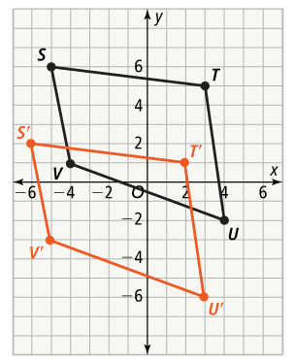
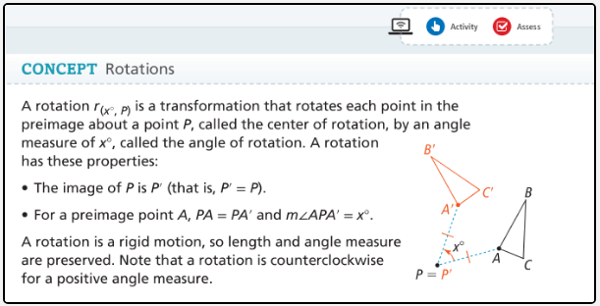
Rules can be used to rotate a figure $90°, 180°, and 270°$ about the origin O in the coordinate plane.

$$r_{\left(90°,O\right)}\left(x,y\right)=$$

$$r_{\left(180°,O\right)}\left(x,y\right)=$$

$$r_{\left(270°,O\right)}\left(x,y\right)=$$

What is $r_{(90°,O)}ABCD?$ What is $r_{(270°,O)}ABCD?$

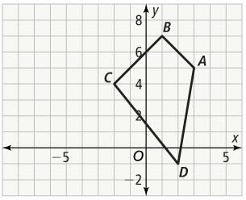

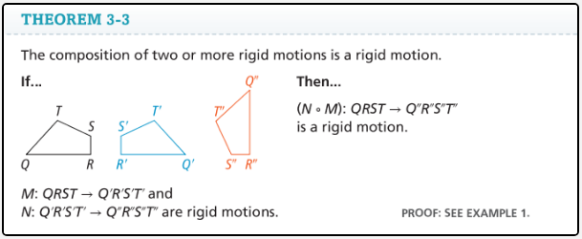
What is the graph of $T_{\left\langle 7,\left.-4\right\rangle \right.} R_{x-axis}(∆EFG)?$
$$°$$
What are the vertices of $∆EFG?$

What are the vertices of $∆E^{'}F^{'}G^{'}$? $∆E^{''}{F'}^{'}G^{''}$?



