Grade 8 Topic 3 Online Assessment (question print out)
Name: _____________________________
1.
Is the relation shown below a function? Use the graph below to justify your response.
(0, 0), (2, 0), (2, 2), and (3, 4)
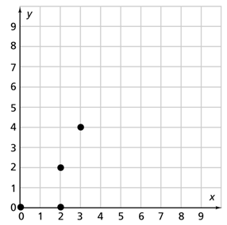
- Yes; Each x-value has a unique y-value.
- Yes; Each y-value has a unique x-value.
- No; Two points have different y-values for the same x-value of 2.
- No; Two points have different x-values for the same y-value of 2.

2.
Are the following functions linear or nonlinear? Drag the tiles to complete the statements.
Tiles may be used once, more than once, or not at all.
Function A | Function B
 | 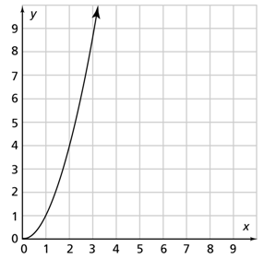
  x | 3 | 6 | 9 | 12 | 15
  y | 5 | 10 | 15 | 20 | 25
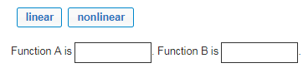

3.
Which function has a greater constant rate of change? Use the drop-down menus to show your answer.
Function A | Function B
 | y = –4.5x + 15
  x | 1.5 | 2.5 | 3.5 | 4.5 | 5.5
  y | 5 | 10 | 15 | 20 | 25

-4.5
4.5
-5
5

5 B
-4.5 A
4.5
-5

4.
How would you describe the graph of the function in interval 2? Select all that apply.
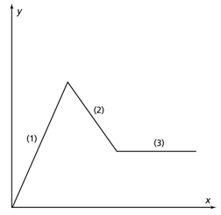
- The function is increasing.
- The slope is negative.
- The function is decreasing.
- The function is constant.
- The slope is positive.

5.
The graph of a function is a line that passes through the coordinates (2, 11) and (8, 14).

Part A
Which shows how to find the rate of change for the function?
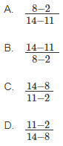

Part B
Which is an equation in terms of x and y for this function?
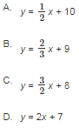

6.
Natasha rides her bicycle to school. She rides slowly uphill for 5 minutes when she first leaves her house, then speeds up and rides at a consistent speed on flat road for 15 minutes. The last 7 minutes of her ride, she goes faster and faster, flies downhill until she arrives at school.

Which graph shows the relationship between Natasha’s speed on her bicycle and time?

- A. 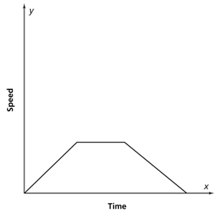 B. 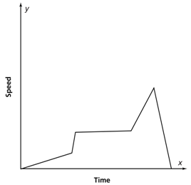

- C. 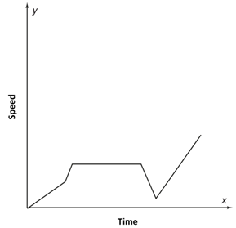 D.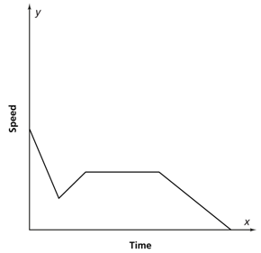

7.
Emma says that Function A has a greater initial value. Is Emma correct? Justify your response.
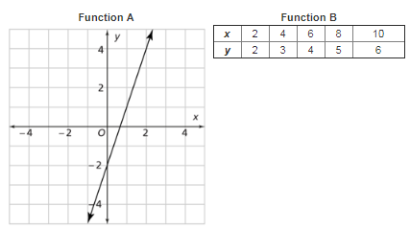
  - Yes; Function A has an initial value of 2 and Function B has an initial value of 1. So, Function A has a greater initial value.
  - Yes; Function A has an initial value of –1 and Function B has an initial value of –2. So, Function A has a greater initial value.
  - No; Function A has an initial value of –2 and Function B has an initial value of 1. So, Function B has a greater initial value.
  - No; Function A has an initial value of 2 and Function B has an initial value of –1. So, Function B has a greater initial value.

8.
A hot air balloon descends from an altitude of 2,000 feet at a constant rate of 90 feet per minute. The graph shows the altitude of the balloon over time. Write a linear function in the form y = mx + b to represent the situation.


