Grade 6 Topic 8 Online Assessment (question print out)
Name: _____________________________

1.
How do you know that this dot plot displays the answers to a statistical question?
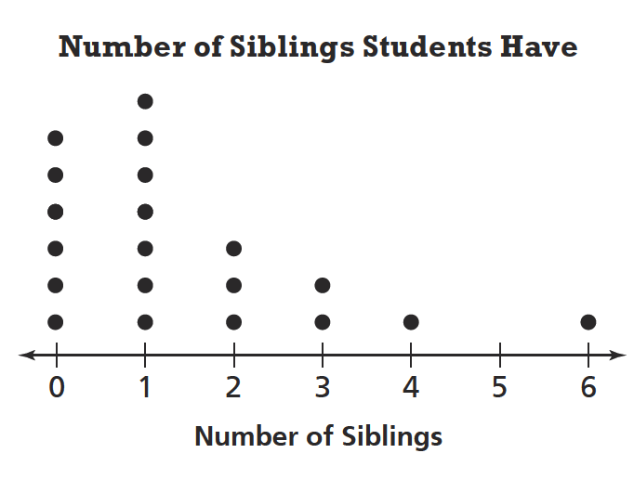

- Various data are shown.
- All data values are the same.
- The data are numerical.
- Students were all asked the same question.

2.
The ages of 10 boys are listed below.
Select Yes or No for each statement.
7, 6, 8, 6, 8, 7, 8, 7, 8, 6


no
yes


yes
no

yes
no

no
yes

3.
Chad earned the following test scores:
70, 85, 100, 87, 80, 70, 95, 91
Drag the correct word to each box to make the inequalities true.
Each term may be used once or not at all.

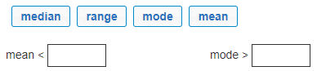

4.
The data show yearly rainfall for a 9-year period in inches:
29, 24, 19, 21, 23, 27, 26, 29, 18
What is the MAD for this set of data in inches?

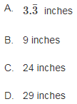

5.
The histogram shows students’ scores on a math test.
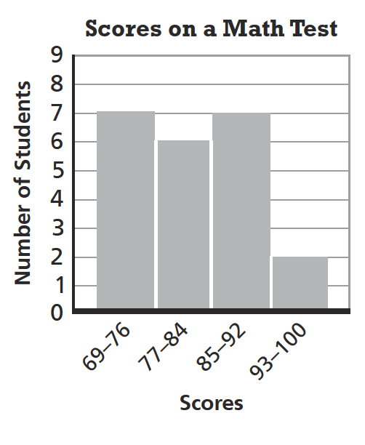
According to the histogram, how many students scored between 85 and 100?
Enter your answer in the box.



6.
Drag numbers that make the statements correct for this box plot.
Numbers may be used once or not at all.
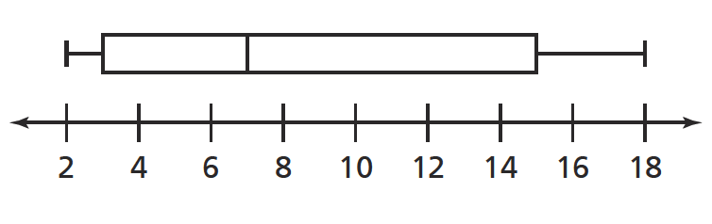



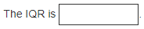
7.
Eight homerooms in a middle school had the following distribution of students.
29, 32, 33, 28, 30, 30, 29, 33
What is the MAD of students?

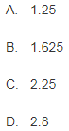

8.
Sebby says that the mean is a better measure of center for the data below because the data is clustered together. Do you agree with Sebby’s reasoning?
Use the drop-down menus to explain and show your answer.
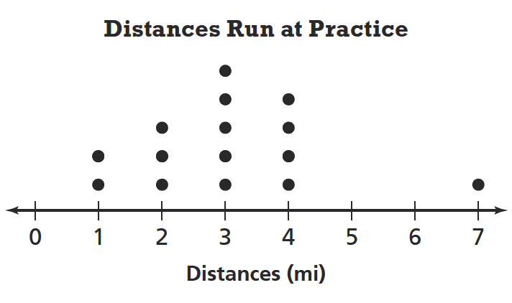

do not does not have
do has


2 is
4 is not
3

is
is not

9.
For each of 7 weeks babysitting, Kelly made the following dollar amounts:
16, 28, 28, 32, 21, 18, 35

What is the first quartile of this data?

Enter your answer in the box.



10.
McKenna kept track of the number of miles she rode her horse each day for 2 weeks.
3, 2.5, 5, 2.5, 8, 10, 4, 0, 6, 6, 2, 2, 6, 9

Part A
Find the measures of center and variability that best summarize McKenna’s data.

Use the dropdown menus to explain your reasoning.

range 10
median 6
mode 4.5

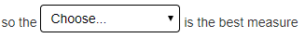
MAD
Range
IRQ

of variability.

Part B
McKenna says that she typically rides her horse for about 6 hours because the mode is 6.

Is McKenna's conclusion appropriate?
Use the dropdown menus to explain your reasoning.

is not
is

is not
is


less
more

less
more

10
0
2.5

