Geometry Name: _________________________________________
Common Assessment 4
Practice Test 1

- Point R is in the interior of ∠PQS. What is m∠RQS?

- Which angle is congruent to ∠2? Select all that apply.

- A. ∠5
- B. ∠6
- C. ∠7
- D. ∠8

- What are the coordinates of the image $R_{x-axis}\left(JKLO\right)=J'K'L'O'$?

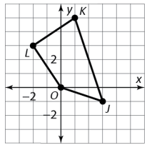 | 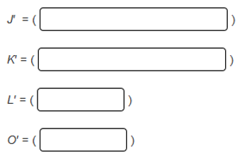

- What is a rule for the translation of $STUV$ to $S'T'U'V'$? Select all that apply.

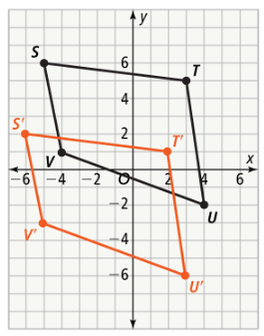 | - A. $T_{<-4,-1>}$  - B. $T_{<-1,-4>}$  - C. 4 units down, 1 unit left  - D. 4 units left, 1 unit down

- What is the perimeter of quadrilateral MQPN?
perimeter of MQPN =

- If $\overline{SU}$ and $\overline{RT}$ bisect each other, which theorem(s) can be used to show that $∆RUV≅∆TSV$? Select all that apply.
- AAS
- SAS
- SSS
- ASA

- If TA = 5.8, what is ZR?
- A. 3.7

- B. 5.8

- C. 2.1

- D. Not enough information

- The diagonals of parallelogram ABCD intersect at Z. Which statement must be true? Select all that apply.

- A. $m∠ABC+m∠CDA=180°$

- B. $\overline{AZ}≅\overline{CZ}$

- C. $\overline{BC}≅\overline{AD}$

- D. $∠ACD≅∠BAC$

- Fill in the blank: How do the angles and side lengths of the preimage relate to the corresponding angles and side lengths of the image of a dilation with a scale factor not equal to one?

The angles are ________________________________ and the side lengths are ________________________________.

- The point B has coordinate B(3, 5). What are the coordinates of $B'$ for the dilation $D_{2.5}(B)$?

$$B'( )$$

- Given $∆VXY$ and $∆VWZ$, what is VW?

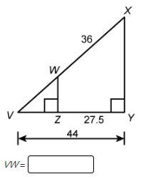

- What is the scale factor of the dilation shown?
- A. $\frac{5}{4}$

- B. $\frac{4}{5}$

- C. $\frac{5}{3}$

- D. $\frac{3}{5}$

- Which conclusion does the diagram support?
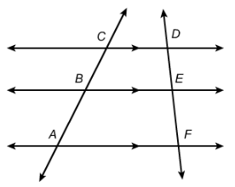 | 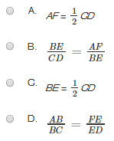

- What is AB?

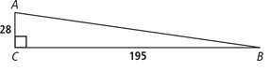
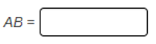

- Answer the questions below:
  - What is a triangle midsegment?

  - What is the relationship between a triangle midsegment and the third side of the triangle?

- What is the cosine ratio of ∠A?

- Which value is equal to $\frac{\sqrt{3}}{2}$? Select all that apply.
- A. $\sin{30°}$

- B. $\cos{45°}$

- C. $\tan{60°}$

- D.$\cos{30°}$

- E. $\tan{45°}$

- F. $\sin{60°}$

- What is m∠P to the nearest tenth?
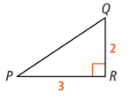

- The angle of elevation from a viewer to the top of a flagpole is 35°. The viewer is 60 ft away and the viewer’s eyes are 4.5 ft from the ground. How high is the pole to the nearest tenth of a foot?


