Grade 6 Topic 7 Online Assessment (question print out)
Name: _____________________________
1.
Caroline is making a triangular flag with a base of 10 inches and a height of 8 inches.
What is the area of the flag?
- 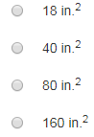

2.
Two figures are arranged as shown. Which of the following can be used to find the area of the figure shaded light gray?
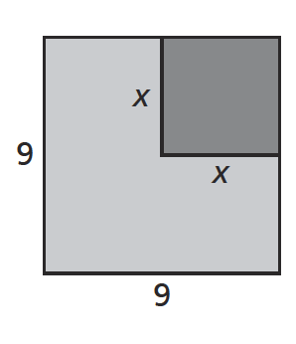
Select all that apply.

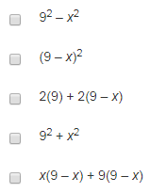

3.
A playground has the shape of a trapezoid.
Part A
The shortest side of the playground and its width have the same dimension.
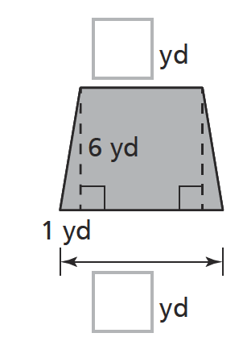
Write numbers in the boxes below to show the missing dimensions in the figure above.
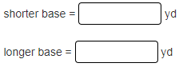

Part B
Use the measurements from Part A to find the area of the playground.

- 18 yd²
- 24 yd²
- 42 yd²
- 84 yd²

4.
Which equation can be used to find A, the area of the parallelogram shown?
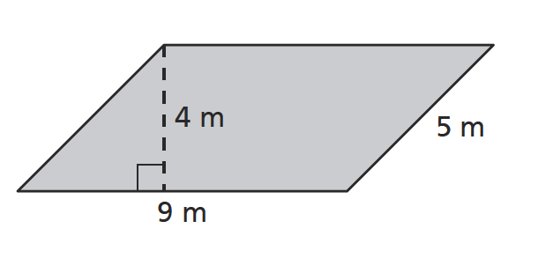
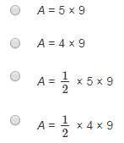
5.
Jake drew the sketch below of a kite that he wants to make.
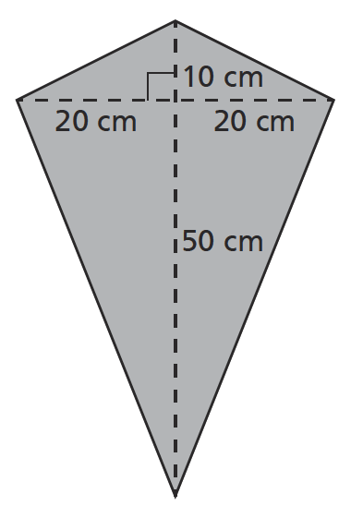
Part A
Which of the following expressions can be used to find the area of the kite? Select all that apply
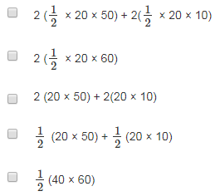

Part B
What is the area of Jake's kite?

Enter your answer in the box.
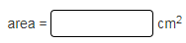

6.
Which of the following can be used to find the volume of a rectangular prism with length 7.5 centimeters, width 2 centimeters, and height 4.2 centimeters?
Select all that apply.

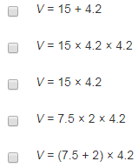

7.
What is the surface area of the triangular prism shown?
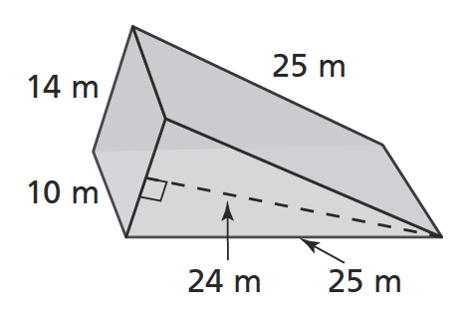

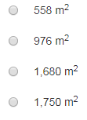

8.
The net below represents a container.
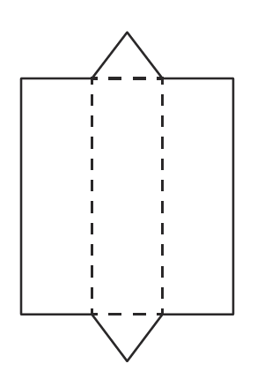
Part A
What solid figure does it show?

- Triangular prism
- Rectangular prism
- Triangular pyramid
- Rectangular pyramid

Part B
How many vertices does the container have?
Enter your answer in the box.

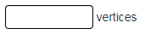

9.
A square pyramid is shown. What is the surface area of the pyramid?
Enter your answer in the box.
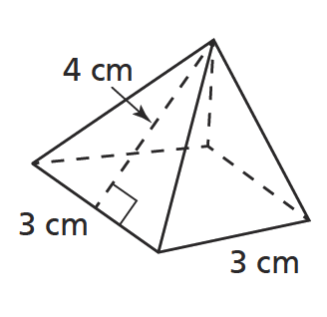
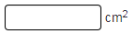
10.

Use the drop-down menus to explain your answer.

does
does not

96
216
60

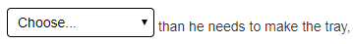
less
more

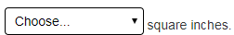
106.5
194.25
25
50

