Graphs of Lines Bump
2 | Graph with slope of 2 |  | Materials: Two die and eight counters per player. Each player uses a different color.
3 | Graph with y-intercept of 2
4 | Graph with negative slope
5 | Graph with positive slope |  | To play:  - On your turn, roll two die and add.  - Read aloud the clue that matches the number you rolled.  - Use a marker to cover a graph that matches the clue.  - If your partner has already covered the graph, say, “Sorry bump!”  - Your partner will remove his counter, and you will claim the graph.  - You can lock a graph if you roll two clues that describe the shape and stack two counters on that shape. Try to be the first to use all of your counters.
6 | Graph with a slope of 2/3
7 | Graph with a y-intercept of 0
8 | Graph with a y-intercept of 4
9 | Graph with a y-intercept of -2
10 | Graph with a y-intercept of -1
11 | Graph with a rate of change of 1
12 | Graph with a rate of change of -3

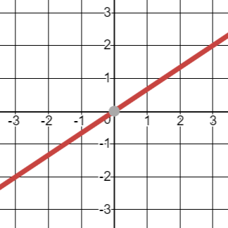 | 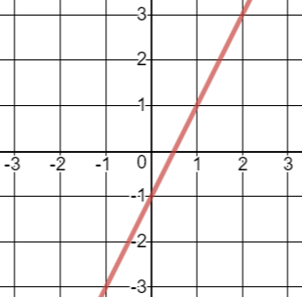 | 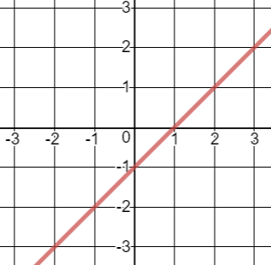 | 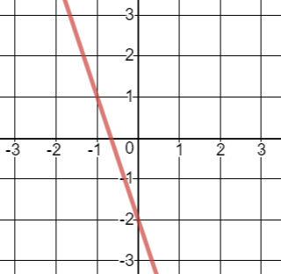
y = 2x | 3x + y = 2 | y = x – 2 | y = (2/3)x + 4
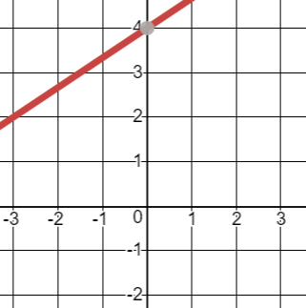 | 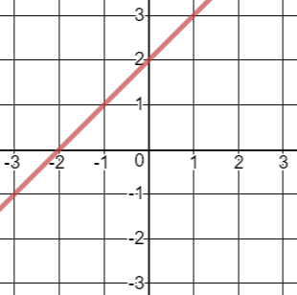 | 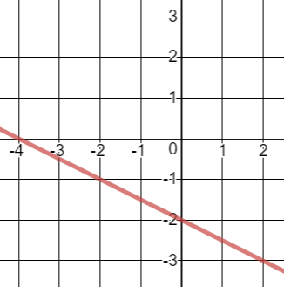 | 

