Grade 8 Topic 8 Online Assessment (question print out)
Name: _____________________________

1.
Jose is wrapping a stack of 100 coins in a paper holder.

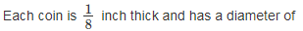
1 inch.

How many square inches of paper will Jose need to cover the stack of coins?
Use 3.14 for π.

Enter your answer in the box.

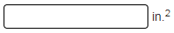

2.
What is the approximate volume of the cylinder?
Use 3.14 for π.
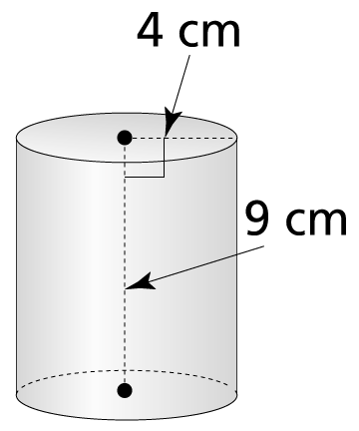

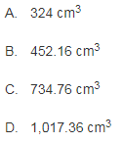

3.
Anita needs to construct ten cones for a class project.
How many square feet of material will she need to construct all ten cones?
Use 3.14 for π. One sample cone is shown below.

Enter your answer for ten cones in the box.
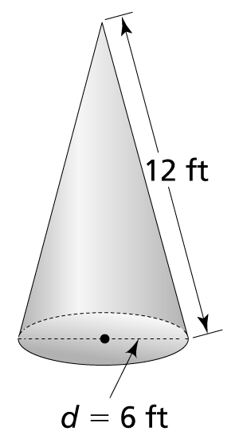

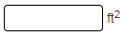

4.
A rectangular prism and a cylinder have the same height.
The length of each side of the prism base is equal to the diameter of the cylinder.

Which shape has a greater volume?

Use the drop-down menus to explain your answer.

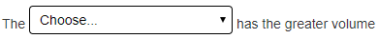
cylinder
rectangular prism

rectangular prism
cylinder
cylinder
rectangular prism

5.
Suppose the radius of a cylinder changes, but its volume stays the same.
How must the height of the cylinder change?
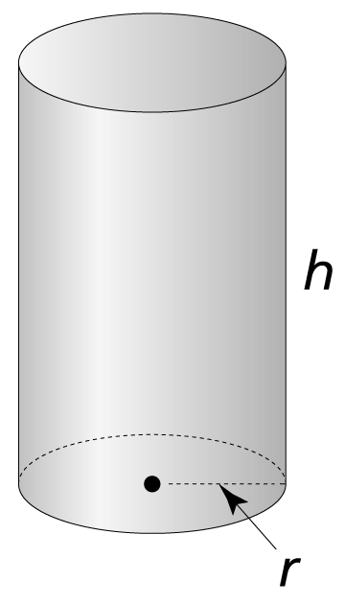
- The height does not change.
- If the radius increases, then the height must increase.
- If the radius decreases, then the height must decrease.
- If the radius increases, then the height must decrease.

6.
What is the approximate volume of the composite figure?
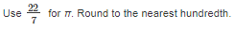

Enter your answer in the box.
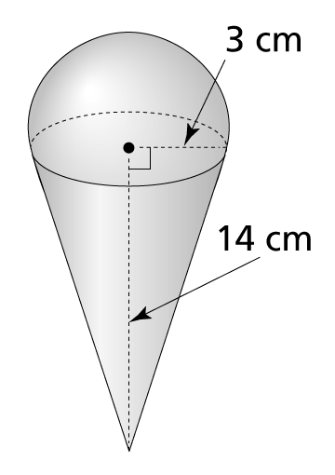
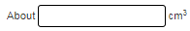

7.
Emmanuel carves a cone-shaped hollow out of a solid clay cylinder.

What is the approximate volume of the solid portion of the cylinder?
Use 3.14 for π.
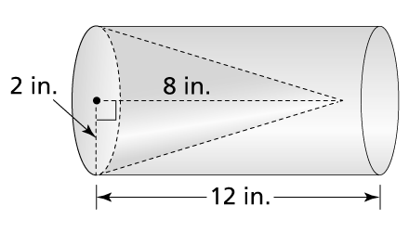

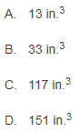

8.
A cylinder has a volume of 400 cubic feet.
If the height of the cylinder is 25 feet, what is the radius of the cylinder?

Use 3.14 for π and round to the nearest hundredth.
Answers MUST be typed to the nearest hundredth to be correct.

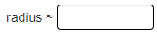

9.
Hal says the volume of the sphere shown below is 36 cm³.
- Find the correct volume, using 3.14 for π. Round to the nearest hundredth.
- What was Hal’s likely error?
Use the drop-down menus to explain your answer.
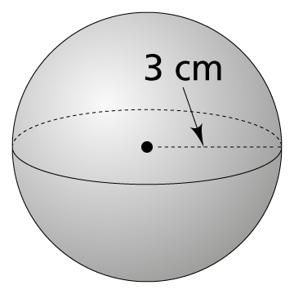
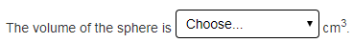
39.14
18
11.46
113.04

greater
less

multiply by
add
divide by
subtract

10.
The surface area of a sphere is 113.04 mm². What is the volume of the sphere?
Use 3.14 for π and round to the nearest hundredth.
- 113.04 mm³
- 628.97 mm³
- 904.32 mm³
- 3,052 mm³

11.
A laser pointer in the shape of a cylinder is 13 centimeters long with a radius of 1 centimeter. It has a cone tip with a height of 3 centimeters. What is the volume of the stylus?
Express your answer in terms of π.


