 | Solving Equations Review | Factoring Review | ACA 3 Review | ACA 3 Review
A – 2/19  B – 2/20 | Solve for n. | Find the product.  (3x – 5$)^{2}$ | Solve the compound inequality | Solve the absolute value equation |x-4|-10 = - 2  (hint: you should get two values for x).
A – 2/21  B – 2/22 | Solve for n. | Factor out the greatest common factor from the polynomial.  12$x^{5}$ – 20$x^{4}$ + 8x | Write an equation that matches the graph? 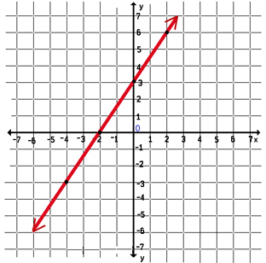 | Write an equation of a line through (-10, -6) and (5, 3)
A – 2/25  B – 2/26 | How many solutions does the equation have? | What is the factored form of  $w^{2}-8w$ + 7 | Find the solution to the system of equations. | Solve the absolute value equation |x – 3|- 18 = - 3
A – 2/27  B – 2/28 | Solve the compound inequality | What is the factored form of  $q^{2}+ qr-12r^{2}$ | Write an inequality that the graph represents? 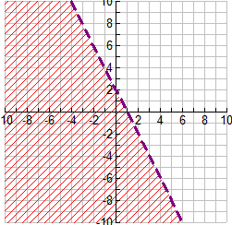 | How many solutions does the system of equations have?
A – 3/1  B – 3/4 | How many solutions does the equation have?  -2x +2(1 + x) = 3(x-1) +8 | Factor Completely  $${2x}^{2}-3x-9$$ | Rewrite the following to show a positive exponent.  $$8^{-20}$$ | Simplify the equation and then write in standard form.  (-6x – 4) – (– 8$x^{2}+9)$
A – 3/5  B – 3/6 | How many solutions does the system of equations have? | Factor the perfect square trinomial $x^{2}-6x+9$ | Evaluate the expression for x = 3 and y = 2.  $${12x}^{0}+3x^{2} w^{-1}$$ | Rewrite the following to show a positive exponent.  $$5^{-7}$$

