Grade 6 Topic 6 Online Assessment (question print out) updated version
Name: _____________________________

1.
Alicia and her father are painting a wall in their basement. Alicia shaded a grid to show how much of the wall they have painted so far.

What percent of the grid is shaded?

- 4%
- 40%
- 60%
- 400%

2.
Margaret is saving money for her summer vacation. She calculates that her starting amount is 0.4% of the total amount she wants to save. What is 0.4% written as a decimal?
A. 0.0004
B. 0.004
C. 0.04
D. 0.5

3.
Most U.S. households spend about 5% of their income on entertainment. Which of the following are equivalent to 5%? Choose all equivalent expressions.
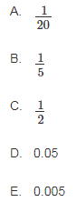

4.
The population of Gilbert increased 275%. Which of the following are equivalent to 275%?
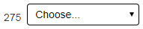
No
Yes
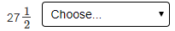
No
Yes
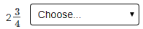
Yes
No
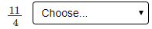
No
Yes
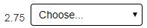
Yes
No
5.
A study found that 9% of dog owners brush their dog’s teeth. Of 578 dog owners, about how many would be expected to brush their dog’s teeth? Explain.

A. 50; 9% ≈ 10% and 578 should be rounded down to 500; 10% of 500 = 50
B. 60; 9% ≈ 10% and 578 ≈ 600; 10% of 600 = 60
C. 70; 9% ≈ 10% and 578 ≈ 700; 10% of 700 = 70
D. 100; 9% ≈ 10% and 578 should be rounded up to 1,000; 10% of 1,000 = 100

6.
- Paula weeded 40% of her garden in 8 minutes. How many minutes will it take her to weed all of her garden?
Part A
Let m = the number of minutes it will take Paula to weed all of the garden.
Choose the equation that can be used to find the solution to the problem.
- A. 0.04m = 8
B. 8m = 0.4
C. m = 0.4 × 8
D. 0.4m = 8

Part B
Use the expression from Part A to find the total number of minutes it will take Paula to weed all of the garden.
Enter your answer in the box.

7.
- The circle graph shows the distribution of students at an elementary school.
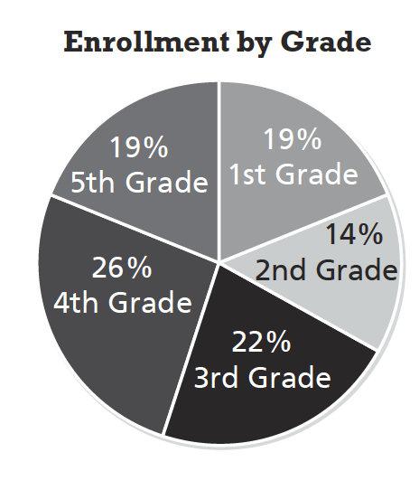
Part A
If there are 205 students in the school, which is the best estimate of the number of students that are in the 5th grade?
- A. 20 students
B. 40 students
C. 45 students
D. 50 students

Part B
Explain how you made your estimate.
19
26
22
14
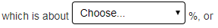
25 1/4
20 1/10
10 1/5
250
200
225
25 1/4
20 1/10
10 1/5

250 40
200 45
225 20
50
8.
All but 4 state capitals have an interstate highway serving them. What percent of 50 is 4?
Enter your answer in the box.



9.
Drag tiles to match each fraction, decimal, or percent to an equivalent number.

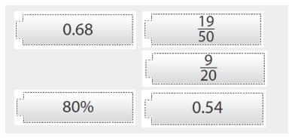

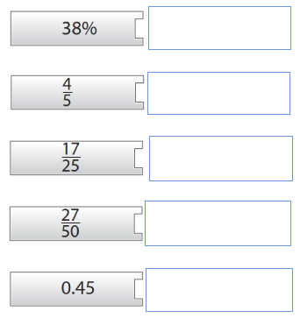

10.
A coat and a pair of boots are on sale for 20% off. The regular price of the coat is $225. The regular price of the boots is $130.
Part A
Use the drop‐down menus to explain how to find the sale price of the coat.
50%
10%
5%
80%

2
10
225
20

divide by
subtract from
add to
multiply by

Part B
Use your answers from Part A to find the sale price for the coat. Enter your answer in the box.

Part C
Ken wants to buy both the coat and the boots.
How much will he pay if he buys both of them during the sale?
- A. $104
- B. $180
C. $284
- D. $355

