Advanced Geometry Name:
10.2 Notes Supplement Date:

Lines Tangent to a Circle

Example 1: Understand Tangents to a Circle

Tangent to a Circle: _________________________________________________________________

____________________________________________________________________________________

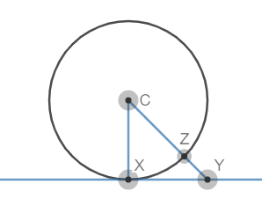
Point of Tangency: ___________________________________________________________________
m

Theorem 10-1: Converse of Theorem 10-1:
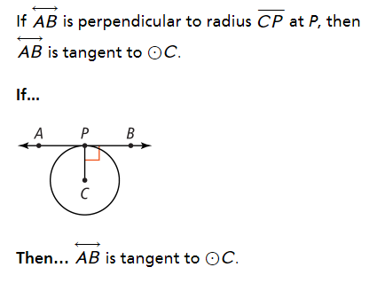
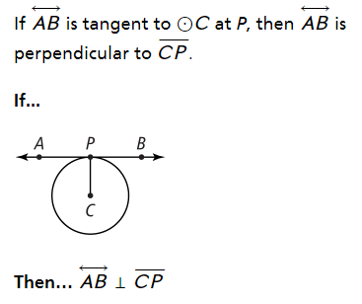

Example 2: Use Tangents to Solve Problems
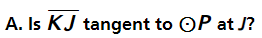

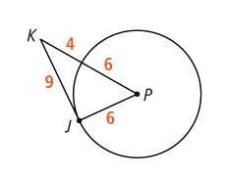

You try:
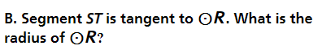

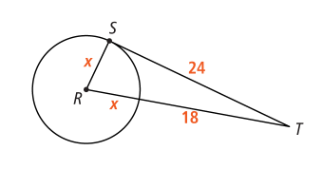

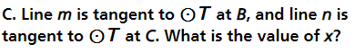

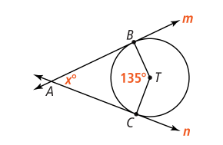

D. Segment BC is tangent to at B. If
BC = 25 and DC = 14, what is the radius of ?
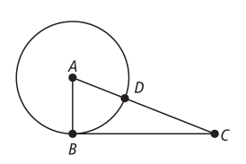

Example 3: Find Lengths of Segments Tangent to Circle
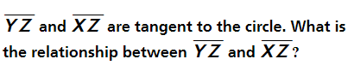

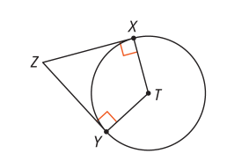

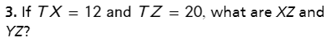
You Try:

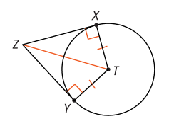

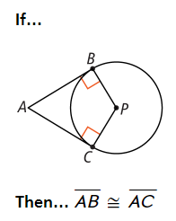
Theorem 10-2:
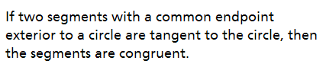

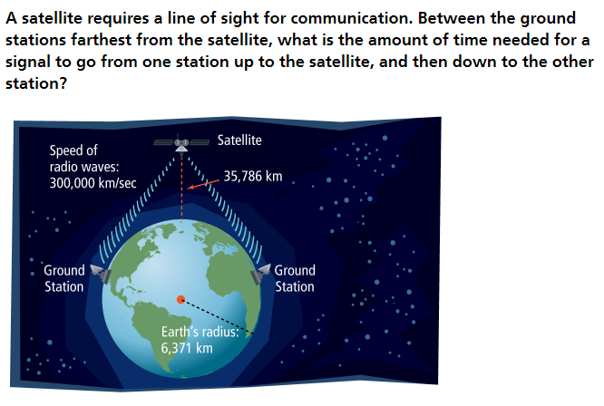
Example 4: Find Measures Involving Tangent Lines

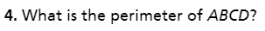
You Try:



