Advanced Geometry Name:
10.2 Notes Supplement Date:

Lines Tangent to a Circle

Example 1: Understand Tangents to a Circle

Tangent to a Circle: _________________________________________________________________

____________________________________________________________________________________

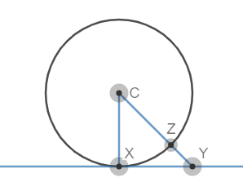
Point of Tangency: ___________________________________________________________________
m
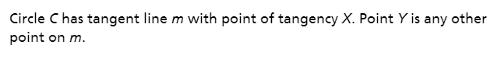

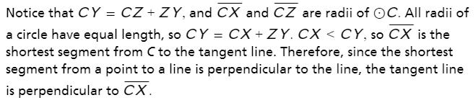

Theorem 10-1: Converse of Theorem 10-1:
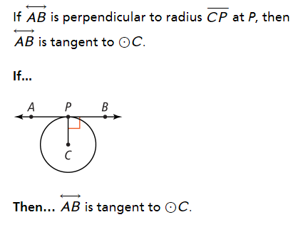
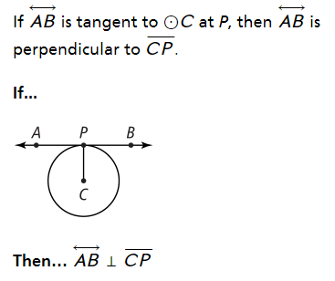

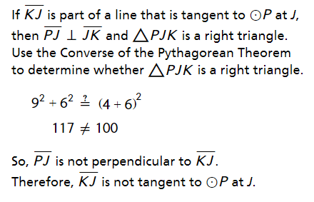
Example 2: Use Tangents to Solve Problems
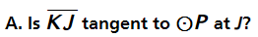

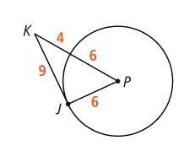

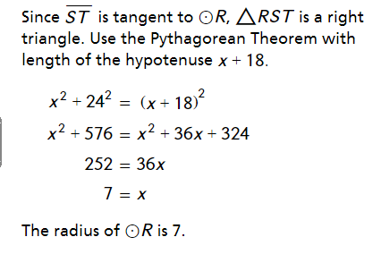
You try:
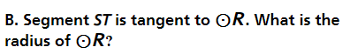

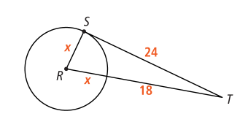

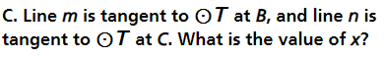
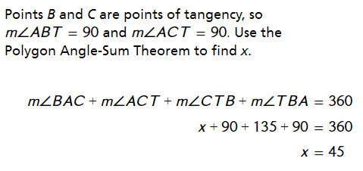
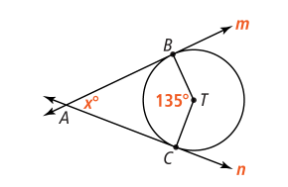

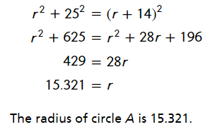
D. Segment BC is tangent to at B. If
BC = 25 and DC = 14, what is the radius of ?
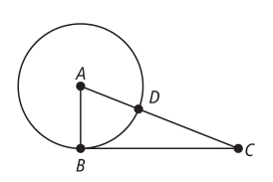

Example 3: Find Lengths of Segments Tangent to Circle
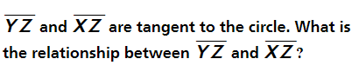

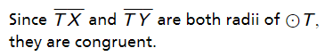
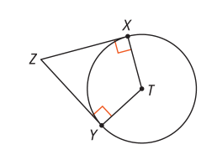

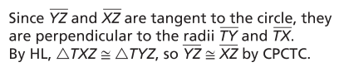

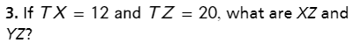
You Try:

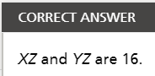
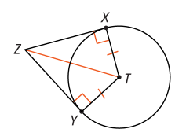

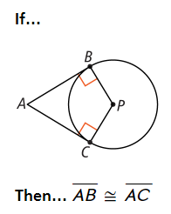
Theorem 10-2:
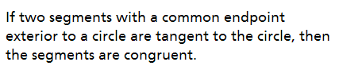

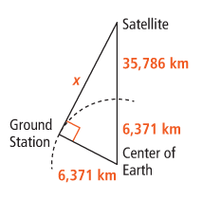
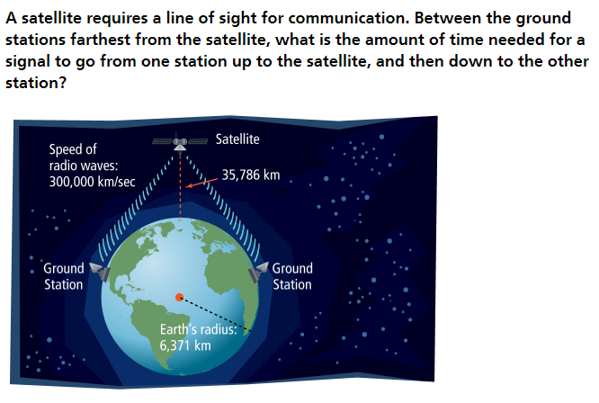
Example 4: Find Measures Involving Tangent Lines

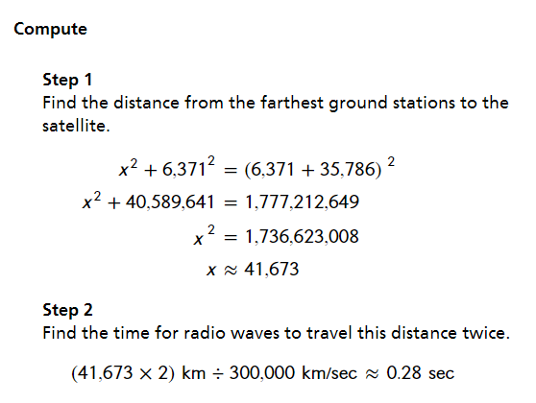

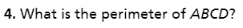
You Try:



