Advanced Geometry Name:
9.3 Notes Supplement Date:

Circles in the Coordinate Plane
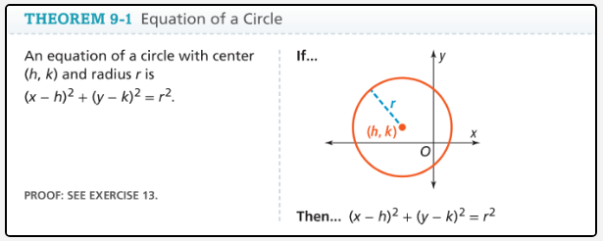

Example 1:

Identify the radius and the center of the circle with the equation ${(x-5)}^{2}+{(y+1)}^{2}=16$

Center: ____________________ Radius: ________________________
---------------------------------------------------------------------------------------------------------------------------------
Example 2: Write the Equation of a Circle
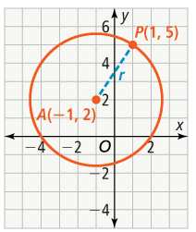
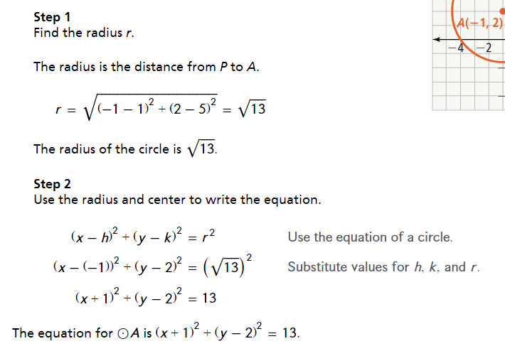

--------------------------------------------------------------------------------------------------------------------------------------

Example 3: Determine Whether a Point Lines on a Circle
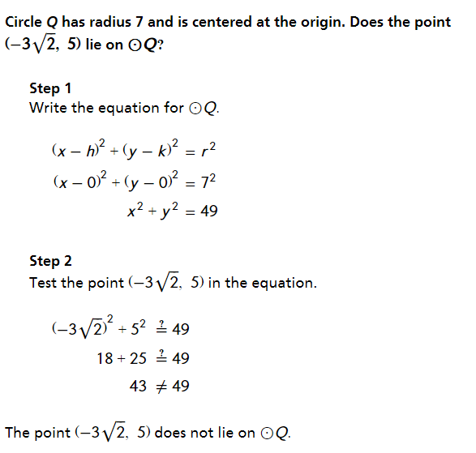

-------------------------------------------------------------------------------------------------------------------------------------
Example 4: Graph a Circle from its Equation
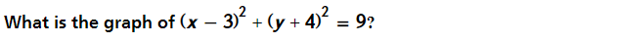

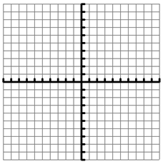
Step 1
Plot the center (h, k) = (3, -4)

Step 2
Identify the radius: $r^{2}=9, thus r=3$
Plot points 3 units above, below, left
and right of the center. Use the points
as a guide to draw the circle.

