Advanced Geometry Name:
10.1 Notes Supplement Date:

Arcs and Sectors
Example 1:
Central angles: ________________________________________________________________________
Given P below, determine if each angle is a central angle. If not, explain.

∠SPN: ________________________________________________

∠NPR: ________________________________________________

∠BAT: ________________________________________________

Intercepted Arcs: __________________________________________________________________________
- One way we measure arcs is in degrees. The measure of an arc tells how many of the 360° of the entire circle the arc takes up. (For example, a 40° arc takes up 40 out of the 360° of a circle.)
There are three types of arcs:

  - Semicircle:______________________________________________________________________

  - Major arc:_ _____________________________________________________________________

  - Minor arc:________________________________________________________________________

 | Measure  (in degrees) | # of letters used to  name the arc
Semicircle
Major arc
Minor arc

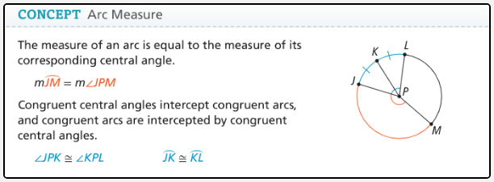

Example 2:
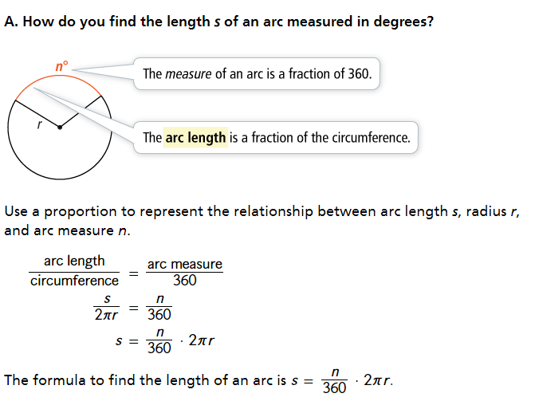

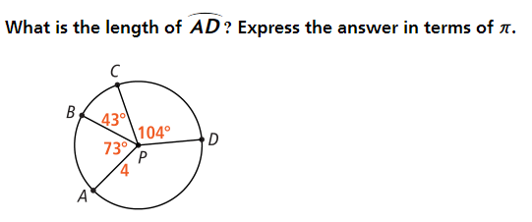
Example 3:

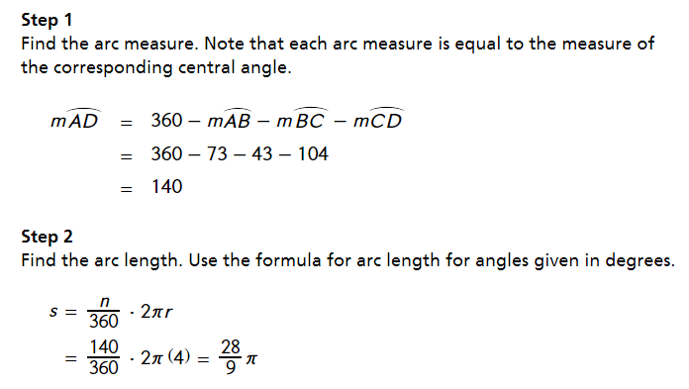

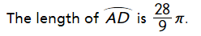

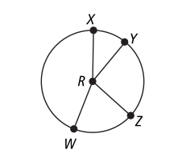
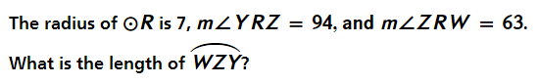
You try:

Example 4:
Sector of a circle: _____________________________________________________________________

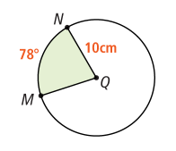
Area of a sector is $A=\frac{n}{360}∙πr^{2}$

What is the area of sector MQN?
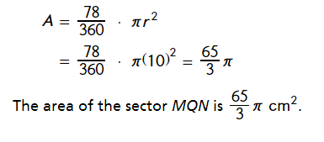

Example 5:
Segment of a circle: ____________________________________________________________________

Area of a segment: ________________________________________________________
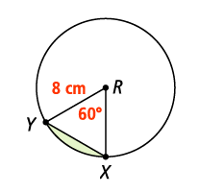
Step 1: Find the area of the sector $A=\frac{n}{360}∙πr^{2}$
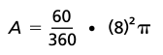

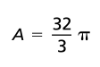

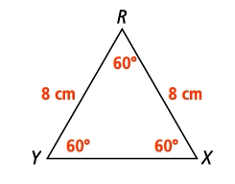
Step 2: Find the area of the triangle $A=\frac{1}{2}bh$
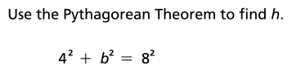
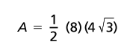

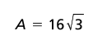
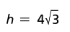

Step 3: Find the area of the segment Area of sector – Area of triangle
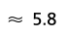
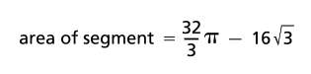


Example 6:


