Advanced Geometry Name:
10.1 Notes Supplement Date:

Arcs and Sectors
Example 1:
Central angles: A central angle is an angle formed by 2 radii with a vertex at the center of a circle.
Given P below, determine if each angle is a central angle. If not, explain.

∠SPN: ________________________________________________

∠NPR: ________________________________________________

∠BAT: ________________________________________________

Intercepted Arcs: Part of a circle that lies between 2 segments, rays, or lines that intersect the circle.
- One way we measure arcs is in degrees. The measure of an arc tells how many of the 360° of the entire circle the arc takes up. (For example, a 40° arc takes up 40 out of the 360° of a circle.)
There are three types of arcs:

  - Semicircle:_an arc that goes half way around the circle – measures 180°_____________________

  - Major arc:_ an arc that is larger than a semicircle – goes more than half way around the circle____

  - Minor arc:_an arc that is smaller than a semicircle – goes less than half way around the circle_____

 | Measure  (in degrees) | # of letters used to  name the arc
Semicircle
Major arc
Minor arc

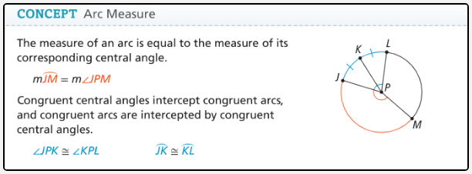

Example 2:
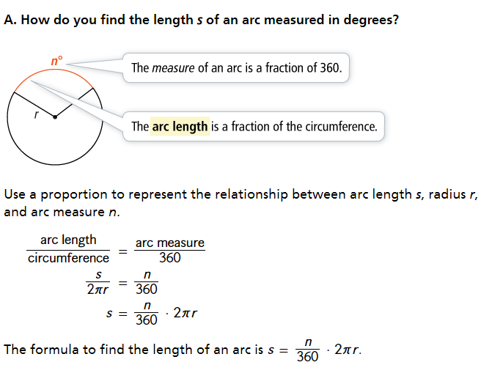

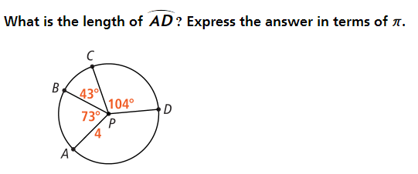
Example 3:

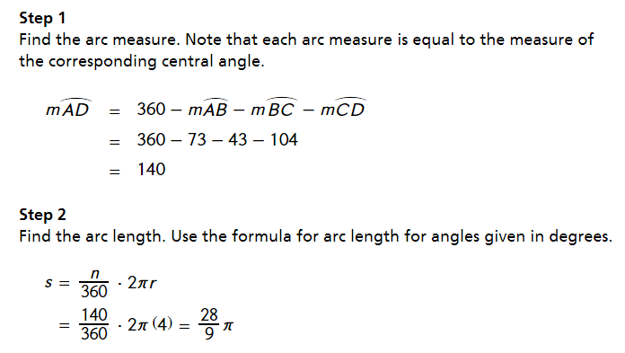

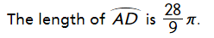

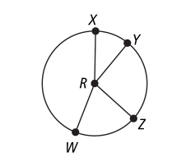
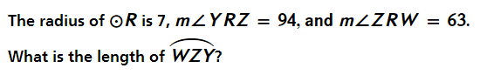
You try:

Example 4:
Sector of a circle: the region bounded by 2 radii and the intercepted arc.________________

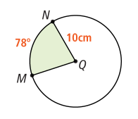
Area of a sector is $A=\frac{n}{360}∙πr^{2}$

What is the area of sector MQN?
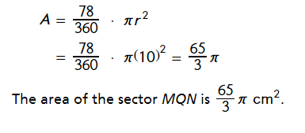

Example 5:
Segment of a circle: part of the circle bounded by an arc and the segment joining its endpoints._________

Area of a segment: Area of sector – Area of triangle
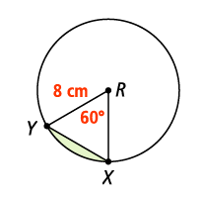
Step 1: Find the area of the sector $A=\frac{n}{360}∙πr^{2}$
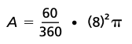

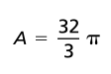

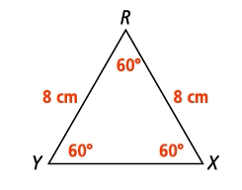
Step 2: Find the area of the triangle $A=\frac{1}{2}bh$
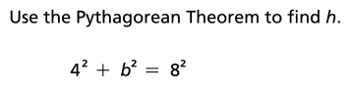
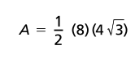

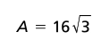
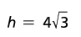

Step 3: Find the area of the segment Area of sector – Area of triangle
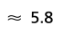
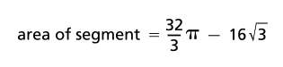

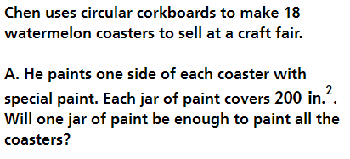
Example 6:


