Algebra 2 Common Assessment 4 Review

1. | P varies inversely with x. If P = -2 when x = 8, find the value of P when x = -16.
2. | What are the horizontal and vertical asymptotes of the graph of y = $\frac{x^{2}+3x-10}{-4-3x+x^{2}}$?
3. | 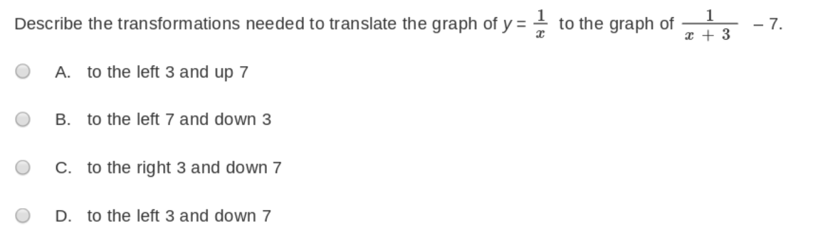
4. | 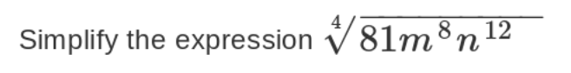  - 3m²n³  - 9m²|n³|  - 3m²|n³|  - 9m⁴n⁶
5. | Simplify $\frac{4}{2+\sqrt{2}}$
6. | The graph of $y=\sqrt{x}$ has been  translated to the left 2 units and  up 1 unit. What is the equation of  the translated graph?  A $y=1+\sqrt{x+2}$  B $y=1-\sqrt{x+2}$  C $y=-1+\sqrt{x-2}$  D $y=-1-\sqrt{x+2}$
7. | The function a has domain x ≥ −2  and range y ≤ 1. What are the  domain and range of a⁻¹?  Domain: Range:
8. | Graph the function $f\left(x\right)=-1+\sqrt{x}$  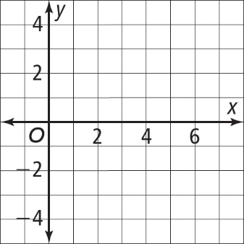
9. | Let f(x)=$\sqrt{x-3}$ and g(x) = $7x$  What is the domain of f ◦ g? Write your answer as an inequality.
10. | If g(x) = 5x – 7, write an equation for g⁻¹(x).
11. | For the function f(x) = $\frac{1}{4}∙3^{x}$, identify the y-intercept and the asymptote.
12. | A school has a population of 2143 students. The population is increasing at a rate of 4% per year. How can you write an exponential growth function to find the monthly growth rate?  A y = 2143(1.0099)^{t}  B y = 2143(1.0033)^{t}  C y = 2143(.4)^{t}  D y = 2143(1.0033)^{12t}
13. | Which function is the inverse of the exponential function y = ${\left(\frac{4}{5}\right)}^{x}$?  A y = ${(x)}^{\frac{4}{5}}$  B y = ${\left(\frac{5}{4}\right)}^{x}$  C y = $\log_{\frac{4}{5}}x$  D y = $\log_{x}\frac{4}{5}$
14. | What is the solution to the equation $\log_{4}\left(2x-1\right)=-1$ ?  Write your solution as a decimal.
15. | 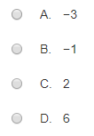  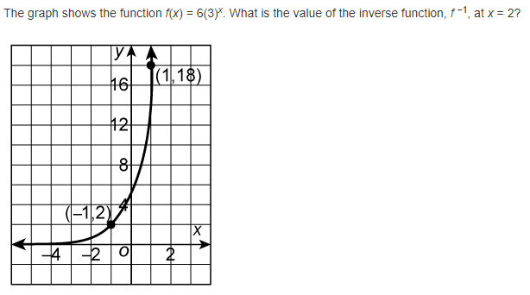
16. | What is the equation of the inverse of the function g(x) = $\log_{4}\left(3x\right)?$  - $y=\frac{1}{3}∙4^{x}$ b. $y=\frac{1}{4}∙3^{x}$ c. $y=\frac{1}{3}∙6^{x}$ d. $y=\frac{1}{3}∙{12}^{x}$
17. | Write an equivalent expression to $log\frac{g^{3}}{a^{2}b^{7}}$
18. | i. Write the explicit formula for the geometric sequence 5, 10, 20, 40, …  a. $a_{n}=5∙{(5)}^{n-1}$ b. $a_{n}=5∙{(5)}^{n+1}$ c. $a_{n}=5∙{(2)}^{n-1}$ d. $a_{n}=5∙{(2)}^{n+1}$  ii. Write the recursive formula for the geometric sequence 5, 10, 20, 40, …  - $a_{n}=\left\{\begin{aligned}5, if n=1 \\ 2∙a_{n-1},if n>1\end{aligned}\right.$ b. $a_{n}=\left\{\begin{aligned}5, if n=2 \\ 2∙a_{n-1},if n>2\end{aligned}\right.$  c. $a_{n}=\left\{\begin{aligned}5, if n=0 \\ 2∙a_{n-1},if n>0\end{aligned}\right.$ d. $a_{n}=\left\{\begin{aligned}2, if n=1 \\ 5∙a_{n-1},if n>1\end{aligned}\right.$  iii. What is the sum of the first 6 terms in the sequence?
19. | What is the domain of the function f(x) = $\frac{x^{2}+3x-18}{x^{2}+4x-12}$ ?  A. x $≠$ 6 or 2 B. x $≠$ 6 or -2 C. x $≠$ -6 or 2 D. x $≠$ -6 or -2
20. | Kenny and Kristin can paint 6 rooms in 14 hours, working together. Kenny can paint 2 rooms in 7 hours, working alone. How many hours would it take Kristin to paint 5 rooms, working alone?
21. | What are the horizontal and vertical asymptotes of the graph y = $\frac{7x-4}{3x+1}$?

