Advanced Geometry Name:
8.2 Notes Supplement Date:

Trigonometric Ratios
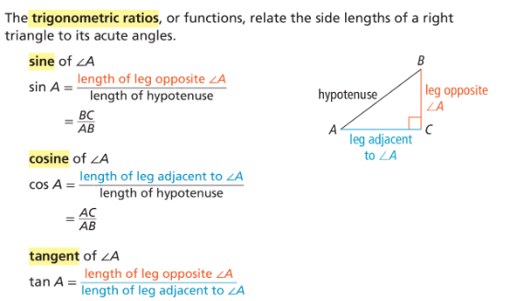

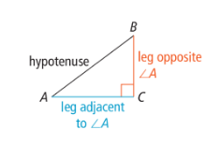

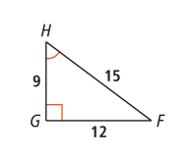
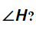
Example 2:
What are the sine, cosine, and tangent ratios for

Example 3:
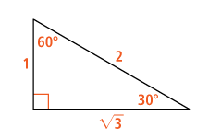
What are the sine, cosine, and tangent ratios for angles?


