Advanced Geometry Name:
7.5 Notes Supplement Date:

7.5 Proportions in Triangles

Example 1: Explore Proportions from Parallel Lines
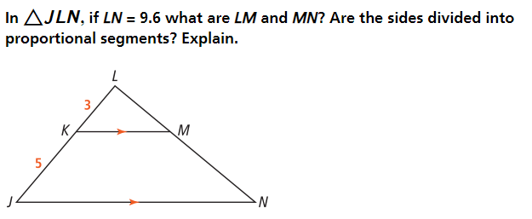

Example 2: Use the Side-Splitter Theorem
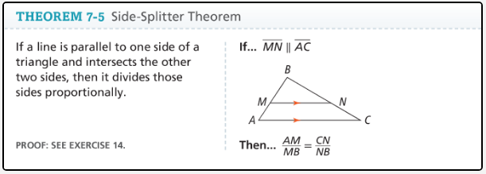

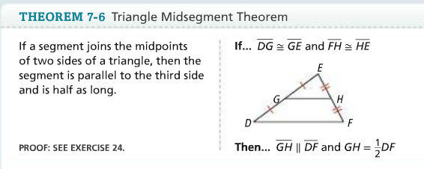

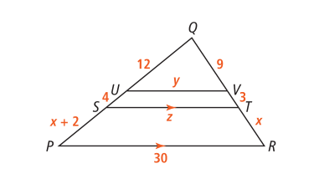

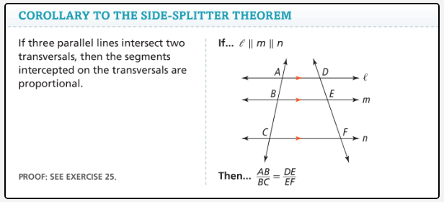

Examples 3: Find a Length
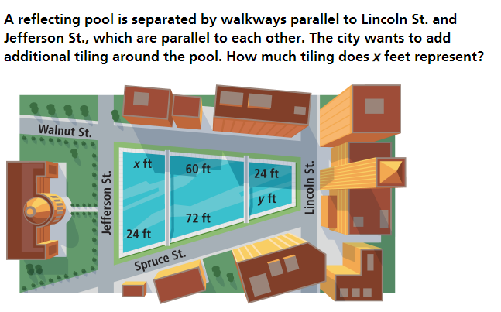

Example 5: Use the Triangle-Angle-Bisector Theorem
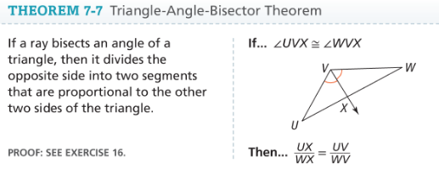
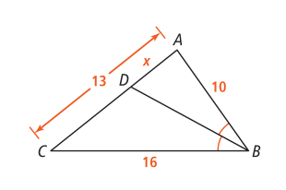
Find AD and DC:

