Advanced Geometry Name:
7.4 Notes Supplement Date:

7.4 Similarity in Right Triangles

Example 1: Identify similar triangles formed by an altitude

When you draw an altitude to the hypotenuse of a right triangle, you create three right triangles. How are the triangles related?
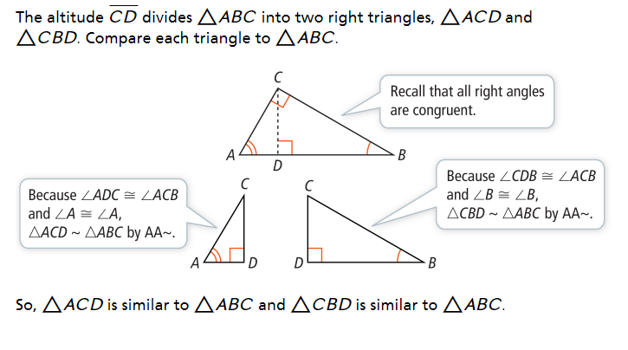

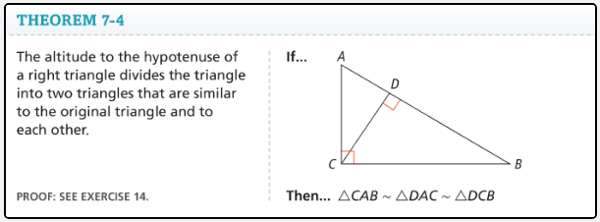

Examples 2: Find missing lengths within right triangles
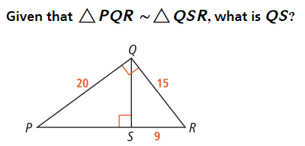

Geometric Mean:
$$Is the number x such that \frac{a}{x}=\frac{x}{b}, where a, b, and x are positive numbers.$$

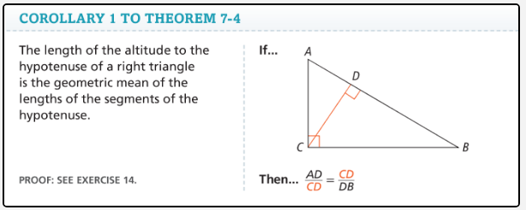

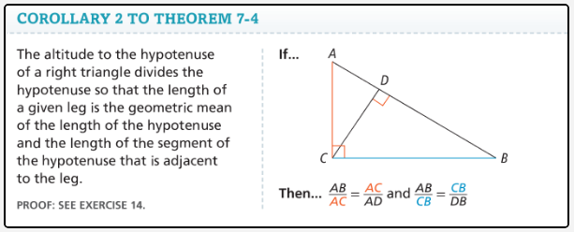

Example 5: Use Geometric Mean to Solve Problems

What is the value of x, y, and z?



