Advanced Geometry Name:
7.3 Notes Supplement Date:

7.3 Proving Triangles Similar

Similar Triangles: _____________________________________________________________

_____________________________________________________________________________

Ways to Prove Triangles Similar:

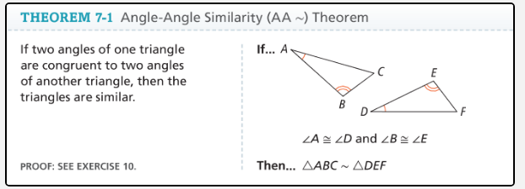

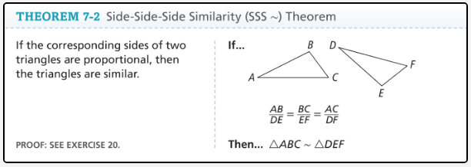

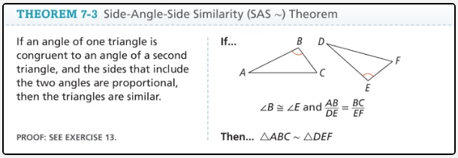

Examples 1- 3: Are the triangles similar? If so, how?
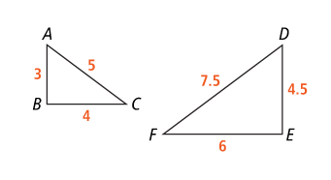
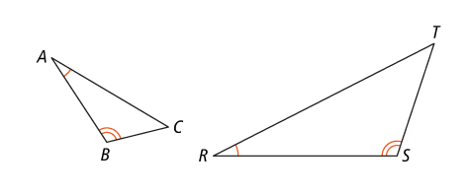
- B.

Example 4: Find lengths in similar triangles.

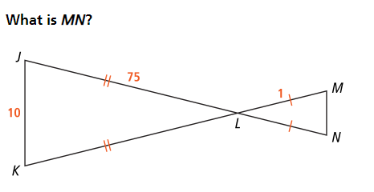

Example 5: Solve problems involving similar triangles.



