Review #1: Algebra 1 Common Assessment 3 Name ____________________
- Solve for x: 9x – 3(2x – 7) = 33

- How many solutions are there to the following equation:
2(4x + 3) – 6x = 3x + 4 – x

- Solve the compound inequality
5 – x < 17 or 3x + 1 < 13

- Solve the absolute value equation
|x – 3| – 10 = -2

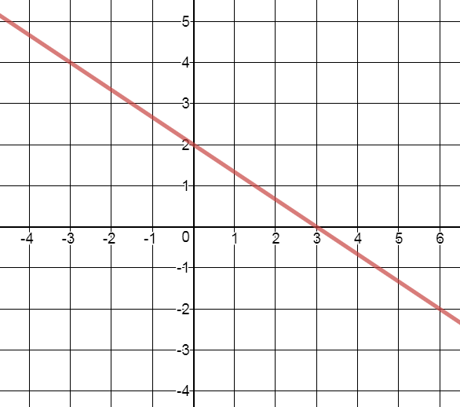
- Write the equation of the graph shown in
slope-intercept form

- Write the equation in slope-intercept form of the line through (6, 9) and (-12, -3)

- What is the solution to the system of equations?
-4x + y = 6
-5x + y = 21

- How many solutions does the following system of equations have?
Y = 5x – 4
-15x – 3y = 12

  - One Solution
  - No Solution
  - Infinitely Many Solutions

- Write an inequality that represents the graph.
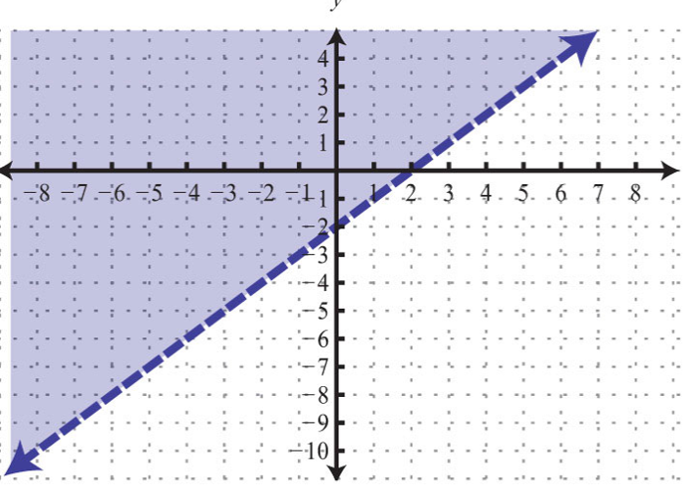

- Simplify. Write your answer in standard form.
(-4x + 6) – (-4x² + 8x – 9)

- Find the product: (6x – 5)²

- Factor out the greatest common factor from the terms of the polynomial:
35x⁴ + 15x² – 10x

- What is the factored form of: y² – 9y + 8

- What is the factored form of: $x^{2}+yx-8y^{2}$

- Factor completely: 6y² – 15y – 36

- Factor the perfect square trinomial: $y^{2}-8y+16$

- Evaluate the expression if x = 4 and y = 1

$${12x}^{0}+4y^{2}* x^{-1}$$

- Rewrite the expression using positive exponents: ${12}^{-3}$

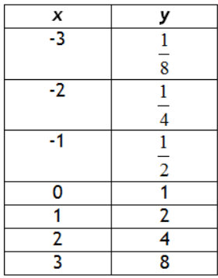
- Which exponential function matches the table?
  - f(x) = $\frac{1}{2}(2)^{x}$
  - f(x) = $\frac{1}{2}(4)^{2}$
  - f(x) = $2^{x}$
  - f(x) = $2^{-x}$

- Is the following a geometric sequence? 36, 12, 4, $\frac{4}{3},….$

