Grade 8 Topic 6 Online Assessment (question print out)
Name: _____________________________

1.
Describe the translation that maps ABCD onto A’B’C’D’?
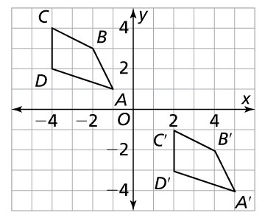

A. Left 6, up 5
B. Left 6, down 5
C. Right 6, up 5
D. Right 6, down 5

2.
The vertices of figure KLMN are K(1, 1), L(4, 1), M(2, 3), and N(5, 3).

If KLMN is reflected across the line y = –1, find the coordinates of vertex L’.

Enter your answers in the boxes.

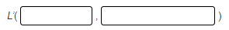

3.
What are the vertices of the resulting image A’B’C’D’E’ after rotating the figure 90° about the origin?
Drag numbers to complete the coordinates.
Numbers may be used once, more than once, or not at all.
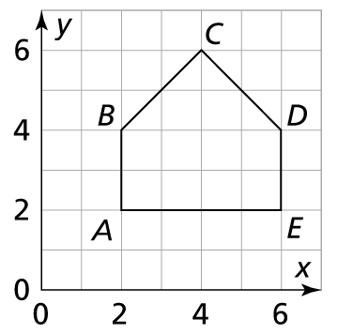

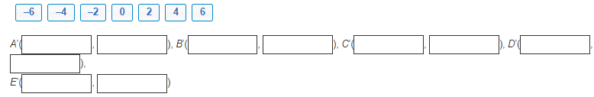
4.
Describe the transformation that maps figure RSTU onto figure R’S’T’U’. Use the drop-down menus to explain your answer.
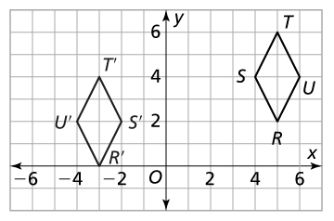
1
3
4
2
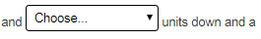
4
1
2
3
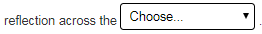
y-axis
x-axis
5.
Consider the figures on the coordinate plane.
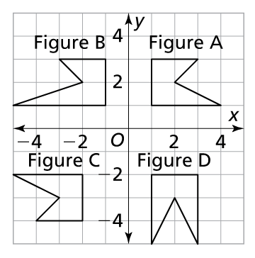
Part A
Which two figures are congruent?
A. Figures A and B
B. Figures A and C
C. Figures A and D
D. Figures C and D

Part B
Describe the sequence of transformations that maps the congruent figures.
Use the drop-down menus to explain your answer.

Figure B 180º
Figure C 360º
Figure A 90º
Figure D 45º

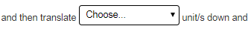
4
2
3
1

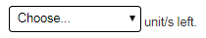
3
4
2
1

6.
Choose the explanation that shows why ΔADE is similar to ΔABC.
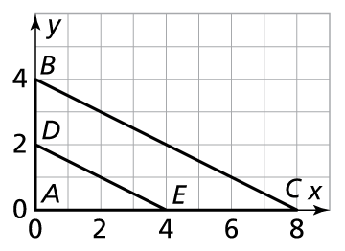
A.
B.
C.
D.

7.
Figure ABCD is similar to figure EFGH. What is the sequence of transformations that maps ABCD to EFGH?
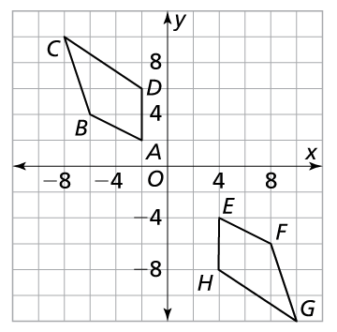

A. Reflection across the x-axis, translation down 4 and right 1.
B. Rotation 180° about the origin, translation down 2 and right 2
C. Rotation 180° about the origin, translation down 2 and right 2
D. Reflection across the x-axis, down 6 and right 3

8.
In the figure, lines a and b are parallel lines. Which of the following statements is true?

Select all that apply.
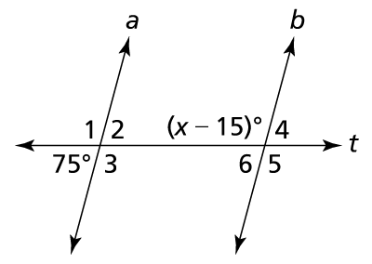

A. m∠1 = m∠6
B. m∠2 = m∠6
C. m∠1 + m∠6 = 180°
D. x = 90°
E. x = 120°

9.
What are m∠1 and m∠2?
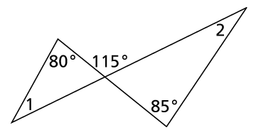

A. ∠1 = 30°, m∠2 = 35°
B. ∠1 = 35°, m∠2 = 30°
C. ∠1 = 65°, m∠2 = 60°
D. ∠1 = 85°, m∠2 = 80°

10.
Choose each angle measure that is one of the angles of these similar triangles.

Select all that apply.
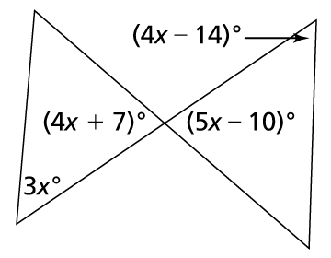
A. 24°
B. 51°
C. 54°
D. 75°
E. 81°

