5 Topic Review

For Items 1–2, find the value of each
expression.
1. $\sqrt{3^{6}}$
2. $\sqrt[3]{-125}$

3. Simplify
a. $\sqrt[4]{16x^{4}y^{8}}$

4. Multiply $(\sqrt{b}+3)(\sqrt{b}-3)$

5. Which of the following is
equivalent to $\frac{4}{1+\sqrt{7}}$
A $\frac{2\sqrt{7}+2}{3}$
B $\frac{2\sqrt{7}+2}{-3}$
C $\frac{2\sqrt{7}-2}{-3}$
D $\frac{2\sqrt{7}-2}{3}$

6. The graph of $y=\sqrt{x}$ has been
translated to the left 2 units and
up 1 unit. What is the equation of
the translated graph?
A $y=1+\sqrt{x+2}$
B $y=1+\sqrt{x-2}$
C $y=-1+\sqrt{x-2}$
D $y=-1-\sqrt{x+2}$
7. The function a has domain x ≥ −2
and range y ≤ 1. What are the
domain and range of a⁻¹?
Domain:
Range:

8. Graph the function $f\left(x\right)=\sqrt{x}-1$
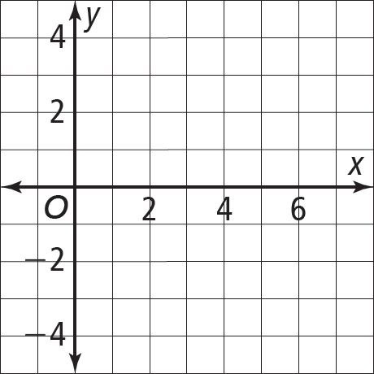

9. Which of the following are real
numbers? Select all that apply.
A C $\sqrt[4]{-16}$
B D $\sqrt[3]{-8}$

10. The volume of a cube is 2.8 m³. Find the length of its edge to the nearest tenth of a meter.

11. Multiply $\sqrt{3}(\sqrt{3}+\sqrt{27)}$
HINT: Use a calculator

12. Which of the following is a
decreasing function?
A $f\left(x\right)= \sqrt{x^{2}}$
B
C
D

13. Let and g(x) = $7-x$ What
is the domain of f ◦ g?
A x > 7 C x > 7
B x < 7 D x < 7

14. If $a\left(x\right)=3-9x$ what is an equation
for $a^{-1}(x)$?
A $a^{-1}=\frac{x-3}{9}$
B $a^{-1}=\frac{x-3}{-9}=\frac{3-x}{9}$
C $a^{-1}=\frac{3-x}{-9}=\frac{x-3}{9}$
D $a^{-1}=\frac{x+3}{9}$

15. Evaluate the expression $\sqrt{x^{2}-5x+22}$ when $x=-2$

16. Some values of f(x) are given in the
table. Find the value of f⁻¹(3).
x | 2 | 3 | -3
f(x) | 3 | 1 | 5

17. A cylindrical pipe is 25 ft long
and has a volume of 900 ft³. Find
its approximate diameter to the
nearest hundredth of a foot. V = Bh
A 3.39 ft C 6.77 ft
B 6 ft D 12 ft

18. Solve ${(x-3)}^{\frac{2}{5}}={(x-1)}^{\frac{1}{5}}$

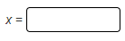

19. $\sqrt{x}+\sqrt{x+5}=5$

20. A store increases all its prices by
20% and then offers a $50 discount
on all purchase prices. Let x
represent the price in dollars. Let
f(x) = 1.20x represent the increase
and g(x) = x − 50 represent the
discount. Which function can the
store manager use to find the final
purchase prices?
A f + g C
B f × g D $\frac{f}{g}$

21. Solve
A 0 C 1.25
B 1 D 2

22. The volume of a sphere is
and the radius is
increasing at 5 mm per second. The
function r(t) = 5t gives the radius
at time t seconds. Which function
gives the volume at time t?
A
B
C (r + V)(t)
D (V ∙ r)(t)

23. Solve the equation $\sqrt{x^{2}}=x$

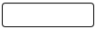
All values of x |

