Grade 8 Topic 4 Online Assessment (question print out)
Name: _____________________________

1.
What type of linear association does the graph show?
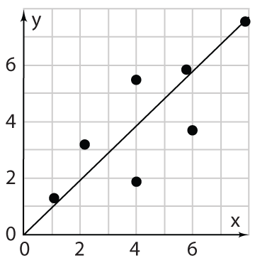
- Strong positive
- Weak positive
- Strong negative
- Weak negative
2.
The two-way frequency table shows the number of social media contacts for 7th- and 8th-graders.
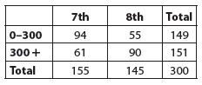
Drag the numbers to complete the column two-way relative frequency table. Numbers may be used once, more than once, or not at all.
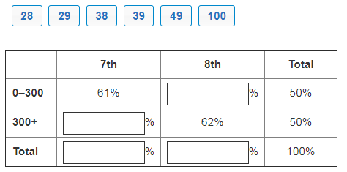

3.

The scatter plot shows the average heights of children up to age 5.
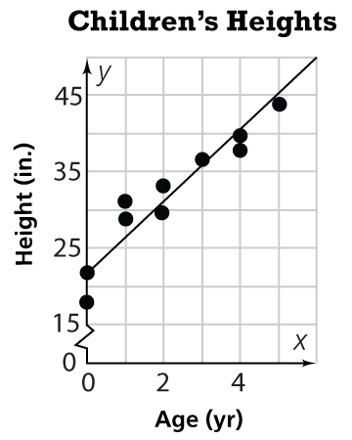

Part A
Drag numbers to complete an equation for the trend line. Numbers may be used once, more than
once, or not at all.

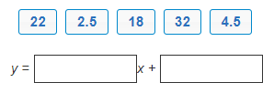

Part B
Using the linear equation, predict the average height for a two-year old.

- 15 inches
- 22 inches
- 31 inches
- 35 inches

4.
The table below shows the ages of employees under 30 at a company and their annual salaries.

Age | Salary
22 | $30,500
24 | $37,000
23 | $35,000
25 | $38,500
22 | $32,000
26 | $43,000
24 | $34,000

Part A
Choose the scatter plot that shows the data.

- B.
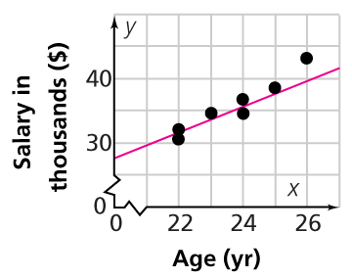. 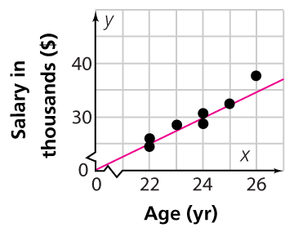

C. D.
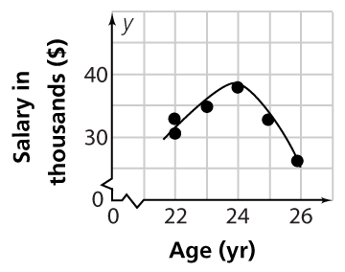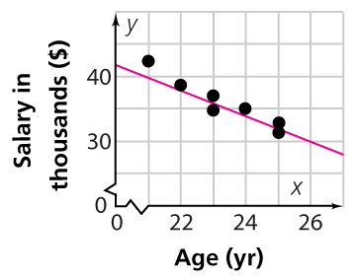

Part B
Use the drop-down menus to describe the relationship between the two sets of data and what it means in the problem situation.
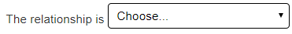
weak negative
nonlinear
strong positive
weak positive
strong negative
less
more

5.
Part A
Complete the two-way frequency table.
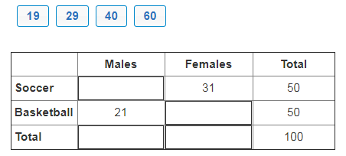
Part B
Which of the following statements is true? Select all that apply.
- More males were surveyed than females.
- More females like soccer.
- An equal number of people like soccer and basketball.
- Twice as many females than males like basketball.

6.
. Select the appropriate linear model for the scatter plot.
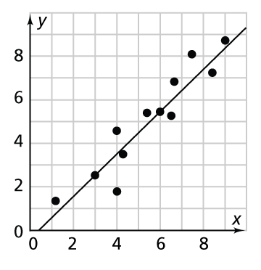
- y = –x + 0.5
- y = –x – 0.5
- y = x + 0.5
- y = x – 0.5

