Grade 6 Topic 4 Online Assessment (question print out)
Name: _____________________________

1.
Drag tiles to match each equation with its solution. Tiles may be used once, more than once, or not at all.
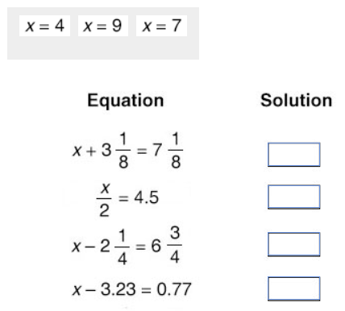

2.
The Martin's van can hold up to 8 passengers.
Part A
Debbie writes the inequality p < 8, where p is the number of passengers that can fit in the van.
Choose the best explanation for Debbie’s error.
- Debbie should have used 8p because 8 passengers can fit in the van.
- Debbie should have switched the inequality symbol to greater than.
- Debbie should have switched the inequality symbol to include 8 as a possible choice.
- Debbie should have used the not equals sign to compare the two sides of the inequality.

Part B
Select the correct inequality symbol to complete the inequality.
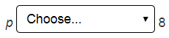
≥
>
≠
≤

3.
Which graph represents the solutions of the inequality z ≤ 7?
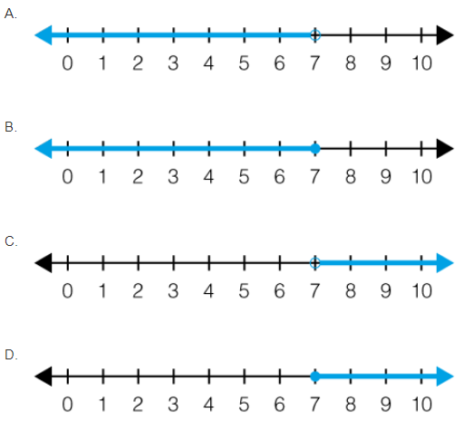

4.
Choose all the equations that are true if y = 6.

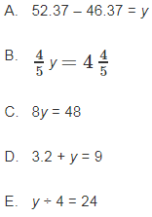

5.
Nehemiah wrote that 4 + 4 = 8. Then he wrote that 4 + 4 – k = 8 – k. Select the phrases that make the statement true.
are
are not
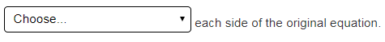
added k to
subtracted k from

6.
Menza has a $500 budget for the school party. She paid $150 for the decorations. Food will cost $5.50 per student. Which inequality represents the number of students, s, that can attend the party?

- 5.5s ≤ 150
- 5.5s ≤ 350
- 5.5s ≤ 500
- 5.5s ≤ 650

7.
When Lana rides her bike from her house to school at a rate of r miles per hour, the trip takes her m minutes. Which statement describes the relationship between r and m?

- r is the independent variable because r affects the number of minutes it takes Lana to ride to school.
- r is the independent variable because m affects how fast she rides her bike.
- r is the dependent variable because m affects how fast she rides her bike.
- r is the dependent variable because r affects the number of minutes it takes Lana to ride to school.

8.
A pet rescue center takes in animals from a local shelter. Half of the animals that they take in are cats.
Let a = the total number of animals.
Let c = the number of cats.
Part A
Which equation represents the problem?
- a = c + 2
- c = a ÷ 2
- c = 2a
- a = c ÷ 2

Part B
Drag numbers to complete the table to show the number of cats, c, that are taken in by the pet rescue when a animals are taken in. Numbers may be used once, more than once, or not at all.

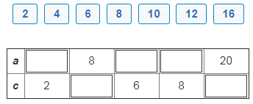

9.

Choose Yes or Not to indicate which of the equations can be used to describe the pattern in the table.

x | 5 | 6 | 7 | 8 | 9
y | 20 | 24 | 28 | 32 | 36

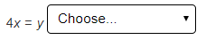
Yes
No

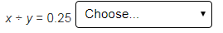
No
Yes

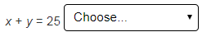
No
Yes

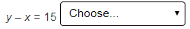
Yes
No

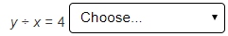
No
Yes

10.
Part A
Which equation was used to graph the line shown?
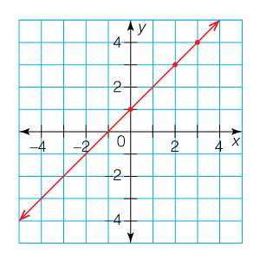
- y = 2x
- y = x ÷ 2
- y = x – 1
- y = x + 1

Part B
Choose all of the ordered pairs that are on the graph of the line.

- (0, 0)
- (2, 3)
- (–2, –1)
- (4, 3)
- (1, 2)

11.



