ABC Sum Race: Systems of Equations

Directions
- Students are placed in groups of three and asked to assign each person in the group a letter (A, B, or C) and identify a team leader.
- The team leader comes to the front of the room to get a task card. The task contains three problems: A, B, and C.
- Each team member solves the problem that corresponds to the letter he or she represents and records the answer on the scorecard.
- Once all answers are recorded, the team adds the answers together to get a sum and records it on the scorecard as well.
- The team leader brings the scorecard to the teacher to be checked. If correct, the group moves on to the next task card. If the sum is wrong, the team must check their work/redo and resubmit.

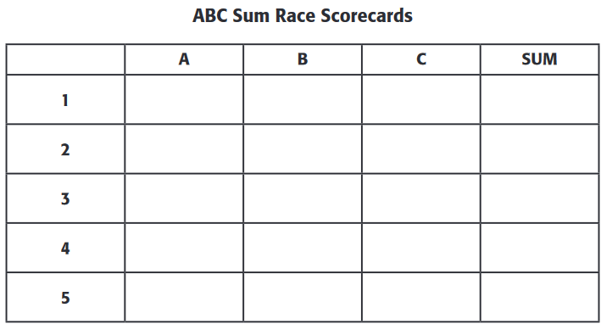

Names:
A ___________________________________________

B ___________________________________________

C ___________________________________________

Card 1: Solve by Graphing
A
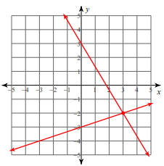

B
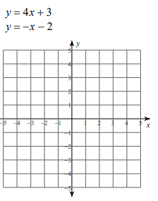
C
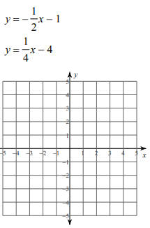
Sum: Find the sum of the x values for each solution.

Card 2: Solve by Substitution
A
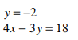
B
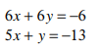
C
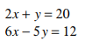
Sum: Find the sum of the x values for each solution

Card 3: Solve by Elimination
A
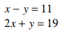

B
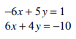
C
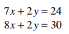
Sum: Find the sum of the y values for each solution.

Card 4: Solve by the Method of Your Choice
A
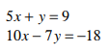
B
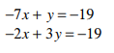
C
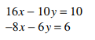
Sum: Find the sum of the y values for each solution.

Card 5: Solve the Real World Problem Using Systems of Equations
A

B
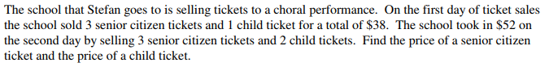

C
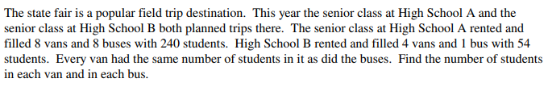

Sum: Find the sum of all answers.

