Equation cards
y = x | y = $\frac{-4}{3}$x | y = 2x
y = -3x | y = -2x | y = -x
y = $\frac{1}{2}x$ | y = $\frac{3}{5} x$ | y = ____

Coordinate pair cards
(-3, 4) | (4, -4) | (-2, 6)
(2, 6) | (__ , __) | (5, 10)
(-4, 8) | (16, 8) | (10, 6)
Graph cards
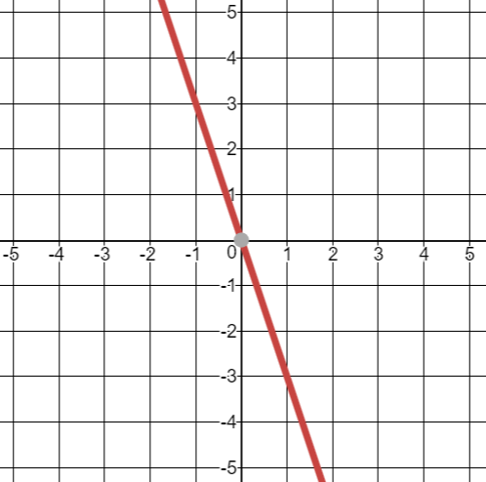 | 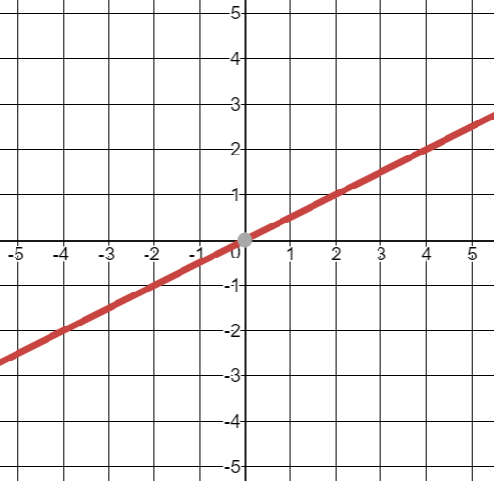 | 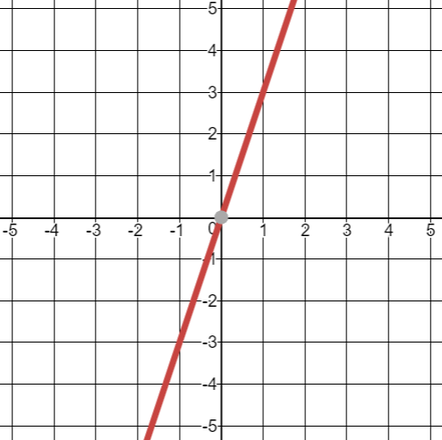
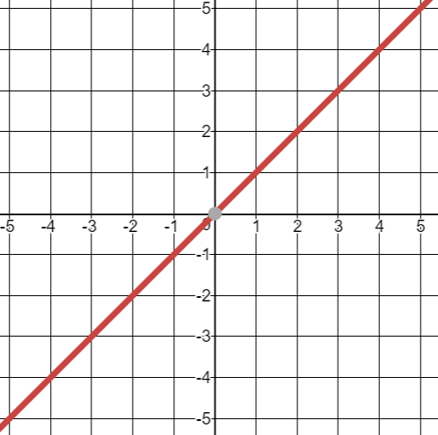 | 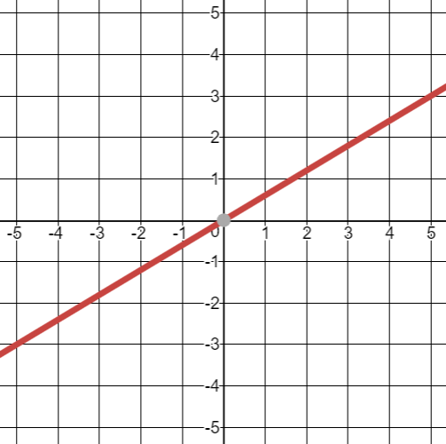 | 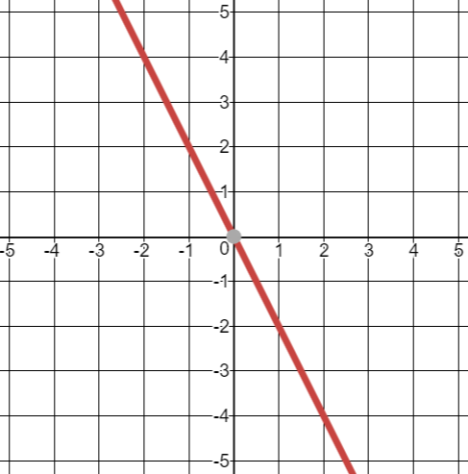
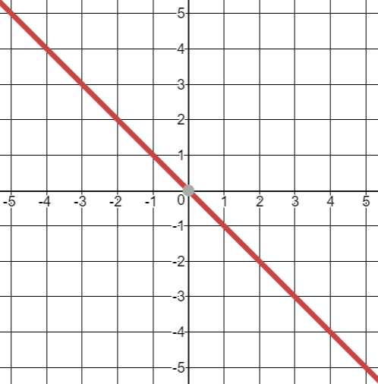 | 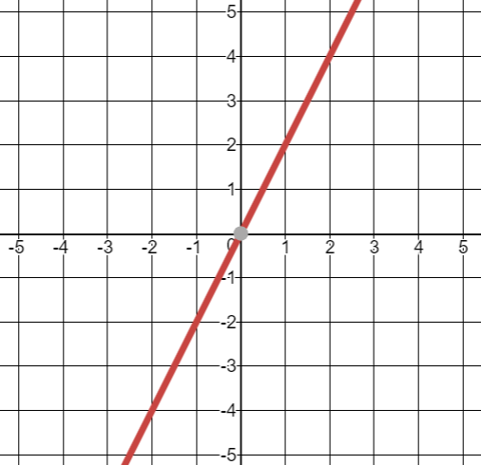 | 

