Topic 3 Functions Mad Lib
Directions: Solve the problem at each station. Identify your answer and fill in the blanks on the back to complete the math lib story.

1 | 2
3 | 4
5 | 6
7 | 8

9 | 10
11 | 12
13 | 14

_____________(1) was late to ______________(2) because ______________(3) was taking __________________(4) to the __________________(5) to buy _____________(6) for __________________(7) . After ________________(8) they took __________________(9) to __________________(10) because they wanted to look at _________________(11) so they could ______________(12) to _____________(13) to ________________(14).
1. Is the relation shown below a function? Use the graph below to justify your response.
(0, 1), (1, 4), (2, 4), (3, 5)
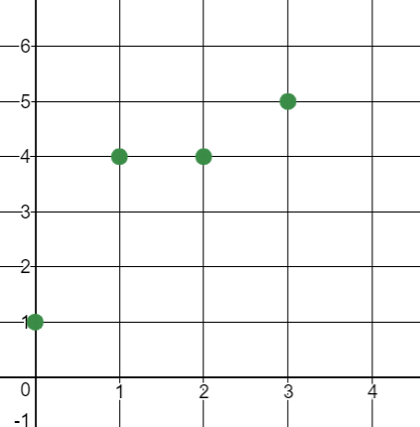
A. Yes; Each x-value has a unique y-value.
B. Yes; Each y value has a unique x-value.
C. No; Two points have different y-values for the
same x-value of 4.
D. No; Two points have different x-values for the same y-value of 4.

A. Kanye West
B. Drake
C. Anthony Davis
D. Benny Snell

2. Determine which of the following is a linear function.
A. B.
x | 0 | 1 | 2 | 3 | 4 |  | x | 0 | 2 | 4 | 6 | 8
y | 0 | 1 | 4 | 9 | 16 |  | y | 0 | 4 | 8 | 12 | 16

C. D.
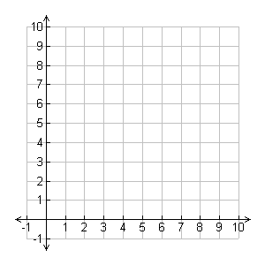

A. the concert
B. practice
C. school
D. church

3. Determine which of the following is a nonlinear function.
A. B.
x | 0 | 1 | 3 | 5 | 7 |  | x | 0 | 2 | 4 | 6 | 8
y | 12 | 7 | 3 | 2 | 6 |  | y | 0 | 4 | 8 | 12 | 16

C. D.

A. Beyonce
B. Ariana Grande
C. Selena Gomez
D. Adele

4. Which function has the greater constant rate of change?
A. B.
x | 1 | 3 | 5 | 7 | 9
y | 7 | 14 | 21 | 28 | 35

B. y = -4x + 6

C. y = x + 9

A. bitcoins
B. bus tokens
C. pennies
D. pencils

5. Which part of the function is increasing?
A. a (mall) B. b (jump zone) C. c (skating rink)

6. Which part of the function is constant? (a) (c)
A. a (candy) B. b (pizza) C. c (tacos) (b)

7. Which part of the function is decreasing?
A. a (Halloween) B. b (thanksgiving) C. c (valentine’s day)

8. Which part of the function has negative slope?
A. a (recess) B. b (math class) C. c (nap time)

9. Which part of the graph has positive slope?
A. a (John Calipari) B. b (Matt Mitchell) C. c (Rick Pitino)

10. The graph of a function is a line that passes through the coordinates (8, 3) and (9, 7). Which shows how to find the rate of change of the function?
A. $\frac{7-3 }{9-8 }$ (Yum Center)
B. $\frac{9-8}{7-3}$ (Rupp Arena)
C. $\frac{9-7}{8-3}$ (The Horse Park)
D. $\frac{9-3}{8-7 }$ (Kroger Field)

11. The graph of a function is a line that passes through the coordinates (8, 3) and (9, 7). Which is an equation in terms of x and y for the equation?

A. y = 4x – 29 (sneakers)
B. y = $\frac{1}{4}x-7$ (headphones)
C. y = 6x + 2 (cell phones)
D. y = $\frac{2}{5}x-1$ (wii games)

12. An airplane ascends for 20 minutes. It flies at its cruising altitude for an hour. Then it descends for 15 minutes. Which graph shows the relationship between the time in flight and the altitude of the airplane?
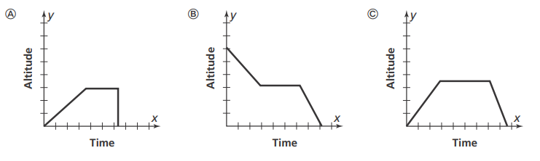

A. bike

B. unicycle

C. hot air balloon

13. Which function has the greater initial value?
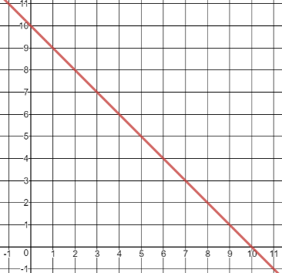
Function A Function B
x | 2 | 4 | 6 | 8 | 10
y | 10 | 9 | 8 | 7 | 6

A. Function A since the initial value is 11.
B. Function B since the initial value is 10.
C. They both have the same initial value.

A. school

B. Walmart

C. Krogers

14. A hiker descends to the canyon floor at a constant rate of 20 feet per minute. The graph shows the height above the canyon floor over time in minutes. Write a linear equation in the form y = mx + b to represent the situation.
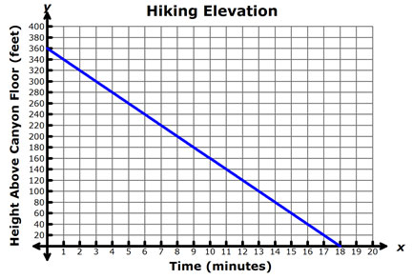
A. y = 18x + 360

B. y = 360x + 18

C. y = -20x + 360

D. y = 20x – 360

A. do homework
B. sing songs
C. walk the dog
D. play basketball

